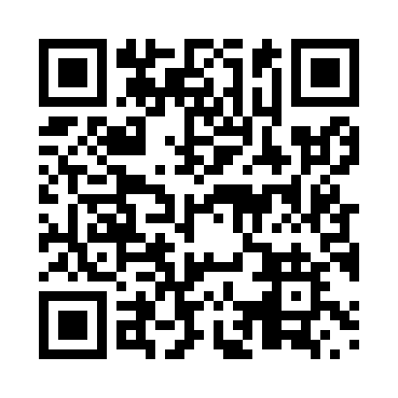
Prayer times for Belcourt, Quebec, Canada
Mon 1 Apr 2024 - Tue 30 Apr 2024
High Latitude Method: Angle Based Rule
Prayer Calculation Method: Islamic Society of North America
Asar Calculation Method: Hanafi

Date | Day | Fajr | Sunrise | Dhuhr | Asr | Maghrib | Isha
1 | Mon | 5:17 | 6:46 | 1:13 | 5:42 | 7:41 | 9:10
2 | Tue | 5:14 | 6:44 | 1:13 | 5:43 | 7:42 | 9:12
3 | Wed | 5:12 | 6:42 | 1:12 | 5:44 | 7:44 | 9:14
4 | Thu | 5:10 | 6:40 | 1:12 | 5:45 | 7:45 | 9:16
5 | Fri | 5:07 | 6:38 | 1:12 | 5:46 | 7:47 | 9:18
6 | Sat | 5:05 | 6:36 | 1:12 | 5:47 | 7:48 | 9:19
7 | Sun | 5:03 | 6:34 | 1:11 | 5:48 | 7:50 | 9:21
8 | Mon | 5:00 | 6:32 | 1:11 | 5:49 | 7:51 | 9:23
9 | Tue | 4:58 | 6:30 | 1:11 | 5:50 | 7:52 | 9:25
10 | Wed | 4:55 | 6:28 | 1:11 | 5:51 | 7:54 | 9:27
11 | Thu | 4:53 | 6:26 | 1:10 | 5:52 | 7:55 | 9:29
12 | Fri | 4:51 | 6:24 | 1:10 | 5:53 | 7:57 | 9:31
13 | Sat | 4:48 | 6:22 | 1:10 | 5:54 | 7:58 | 9:33
14 | Sun | 4:46 | 6:20 | 1:10 | 5:55 | 8:00 | 9:34
15 | Mon | 4:43 | 6:18 | 1:09 | 5:56 | 8:01 | 9:36
16 | Tue | 4:41 | 6:16 | 1:09 | 5:57 | 8:03 | 9:38
17 | Wed | 4:39 | 6:14 | 1:09 | 5:58 | 8:04 | 9:40
18 | Thu | 4:36 | 6:12 | 1:09 | 5:59 | 8:06 | 9:42
19 | Fri | 4:34 | 6:11 | 1:08 | 6:00 | 8:07 | 9:44
20 | Sat | 4:31 | 6:09 | 1:08 | 6:01 | 8:09 | 9:46
21 | Sun | 4:29 | 6:07 | 1:08 | 6:01 | 8:10 | 9:48
22 | Mon | 4:26 | 6:05 | 1:08 | 6:02 | 8:11 | 9:50
23 | Tue | 4:24 | 6:03 | 1:08 | 6:03 | 8:13 | 9:52
24 | Wed | 4:22 | 6:01 | 1:07 | 6:04 | 8:14 | 9:54
25 | Thu | 4:19 | 6:00 | 1:07 | 6:05 | 8:16 | 9:57
26 | Fri | 4:17 | 5:58 | 1:07 | 6:06 | 8:17 | 9:59
27 | Sat | 4:14 | 5:56 | 1:07 | 6:07 | 8:19 | 10:01
28 | Sun | 4:12 | 5:54 | 1:07 | 6:08 | 8:20 | 10:03
29 | Mon | 4:10 | 5:53 | 1:07 | 6:09 | 8:22 | 10:05
30 | Tue | 4:07 | 5:51 | 1:07 | 6:10 | 8:23 | 10:07
Prayer times provided by https://www.salahtimes.com

