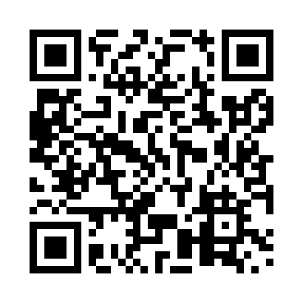
Prayer times for The Bluff, New Brunswick, Canada
Mon 1 Apr 2024 - Tue 30 Apr 2024
High Latitude Method: Angle Based Rule
Prayer Calculation Method: Islamic Society of North America
Asar Calculation Method: Hanafi

Date | Day | Fajr | Sunrise | Dhuhr | Asr | Maghrib | Isha
1 | Mon | 5:31 | 6:57 | 1:22 | 5:51 | 7:47 | 9:13
2 | Tue | 5:29 | 6:55 | 1:21 | 5:52 | 7:49 | 9:15
3 | Wed | 5:27 | 6:53 | 1:21 | 5:53 | 7:50 | 9:16
4 | Thu | 5:25 | 6:51 | 1:21 | 5:54 | 7:51 | 9:18
5 | Fri | 5:23 | 6:49 | 1:21 | 5:55 | 7:53 | 9:19
6 | Sat | 5:20 | 6:47 | 1:20 | 5:55 | 7:54 | 9:21
7 | Sun | 5:18 | 6:45 | 1:20 | 5:56 | 7:55 | 9:23
8 | Mon | 5:16 | 6:43 | 1:20 | 5:57 | 7:57 | 9:24
9 | Tue | 5:14 | 6:42 | 1:19 | 5:58 | 7:58 | 9:26
10 | Wed | 5:12 | 6:40 | 1:19 | 5:59 | 7:59 | 9:28
11 | Thu | 5:09 | 6:38 | 1:19 | 6:00 | 8:01 | 9:29
12 | Fri | 5:07 | 6:36 | 1:19 | 6:01 | 8:02 | 9:31
13 | Sat | 5:05 | 6:34 | 1:18 | 6:02 | 8:03 | 9:33
14 | Sun | 5:03 | 6:32 | 1:18 | 6:03 | 8:05 | 9:35
15 | Mon | 5:01 | 6:30 | 1:18 | 6:04 | 8:06 | 9:36
16 | Tue | 4:58 | 6:29 | 1:18 | 6:04 | 8:07 | 9:38
17 | Wed | 4:56 | 6:27 | 1:17 | 6:05 | 8:09 | 9:40
18 | Thu | 4:54 | 6:25 | 1:17 | 6:06 | 8:10 | 9:42
19 | Fri | 4:52 | 6:23 | 1:17 | 6:07 | 8:11 | 9:43
20 | Sat | 4:50 | 6:22 | 1:17 | 6:08 | 8:13 | 9:45
21 | Sun | 4:47 | 6:20 | 1:17 | 6:09 | 8:14 | 9:47
22 | Mon | 4:45 | 6:18 | 1:16 | 6:09 | 8:15 | 9:49
23 | Tue | 4:43 | 6:16 | 1:16 | 6:10 | 8:17 | 9:51
24 | Wed | 4:41 | 6:15 | 1:16 | 6:11 | 8:18 | 9:52
25 | Thu | 4:39 | 6:13 | 1:16 | 6:12 | 8:19 | 9:54
26 | Fri | 4:37 | 6:11 | 1:16 | 6:13 | 8:21 | 9:56
27 | Sat | 4:34 | 6:10 | 1:16 | 6:14 | 8:22 | 9:58
28 | Sun | 4:32 | 6:08 | 1:15 | 6:14 | 8:23 | 10:00
29 | Mon | 4:30 | 6:07 | 1:15 | 6:15 | 8:25 | 10:02
30 | Tue | 4:28 | 6:05 | 1:15 | 6:16 | 8:26 | 10:03
Prayer times provided by https://www.salahtimes.com

