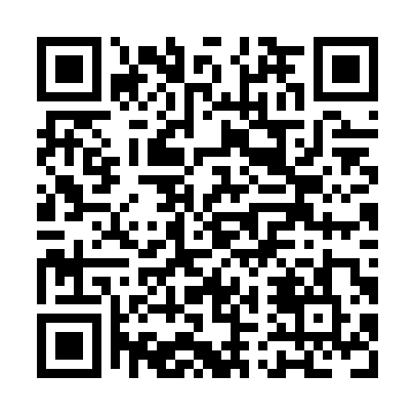
Prayer times for Glover's Harbour, Newfoundland and Labrador, Canada
Mon 1 Apr 2024 - Tue 30 Apr 2024
High Latitude Method: Angle Based Rule
Prayer Calculation Method: Islamic Society of North America
Asar Calculation Method: Hanafi

Date | Day | Fajr | Sunrise | Dhuhr | Asr | Maghrib | Isha
1 | Mon | 5:16 | 6:48 | 1:16 | 5:44 | 7:44 | 9:16
2 | Tue | 5:14 | 6:46 | 1:15 | 5:45 | 7:46 | 9:18
3 | Wed | 5:11 | 6:44 | 1:15 | 5:46 | 7:47 | 9:20
4 | Thu | 5:09 | 6:42 | 1:15 | 5:47 | 7:49 | 9:22
5 | Fri | 5:07 | 6:40 | 1:14 | 5:48 | 7:50 | 9:24
6 | Sat | 5:04 | 6:37 | 1:14 | 5:49 | 7:52 | 9:26
7 | Sun | 5:02 | 6:35 | 1:14 | 5:50 | 7:53 | 9:27
8 | Mon | 4:59 | 6:33 | 1:14 | 5:51 | 7:55 | 9:29
9 | Tue | 4:57 | 6:31 | 1:13 | 5:52 | 7:56 | 9:31
10 | Wed | 4:54 | 6:29 | 1:13 | 5:54 | 7:58 | 9:33
11 | Thu | 4:52 | 6:27 | 1:13 | 5:55 | 8:00 | 9:35
12 | Fri | 4:49 | 6:25 | 1:13 | 5:56 | 8:01 | 9:37
13 | Sat | 4:47 | 6:23 | 1:12 | 5:57 | 8:03 | 9:39
14 | Sun | 4:44 | 6:21 | 1:12 | 5:58 | 8:04 | 9:41
15 | Mon | 4:41 | 6:19 | 1:12 | 5:59 | 8:06 | 9:43
16 | Tue | 4:39 | 6:17 | 1:12 | 6:00 | 8:07 | 9:46
17 | Wed | 4:36 | 6:15 | 1:11 | 6:01 | 8:09 | 9:48
18 | Thu | 4:34 | 6:13 | 1:11 | 6:02 | 8:10 | 9:50
19 | Fri | 4:31 | 6:11 | 1:11 | 6:03 | 8:12 | 9:52
20 | Sat | 4:29 | 6:09 | 1:11 | 6:04 | 8:13 | 9:54
21 | Sun | 4:26 | 6:07 | 1:11 | 6:05 | 8:15 | 9:56
22 | Mon | 4:24 | 6:05 | 1:10 | 6:06 | 8:16 | 9:58
23 | Tue | 4:21 | 6:03 | 1:10 | 6:07 | 8:18 | 10:00
24 | Wed | 4:19 | 6:01 | 1:10 | 6:08 | 8:19 | 10:03
25 | Thu | 4:16 | 6:00 | 1:10 | 6:09 | 8:21 | 10:05
26 | Fri | 4:14 | 5:58 | 1:10 | 6:09 | 8:22 | 10:07
27 | Sat | 4:11 | 5:56 | 1:10 | 6:10 | 8:24 | 10:09
28 | Sun | 4:08 | 5:54 | 1:09 | 6:11 | 8:25 | 10:12
29 | Mon | 4:06 | 5:52 | 1:09 | 6:12 | 8:27 | 10:14
30 | Tue | 4:03 | 5:51 | 1:09 | 6:13 | 8:28 | 10:16
Prayer times provided by https://www.salahtimes.com

