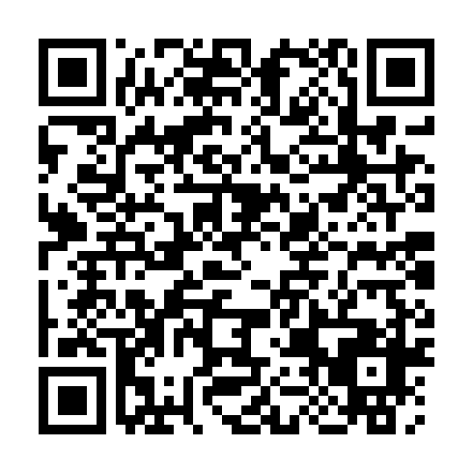
Prayer times for Burnt Point - Gull Island - Northern Bay, Newfoundland and Labrador, Canada
Wed 1 May 2024 - Fri 31 May 2024
High Latitude Method: Angle Based Rule
Prayer Calculation Method: Islamic Society of North America
Asar Calculation Method: Hanafi

Date | Day | Fajr | Sunrise | Dhuhr | Asr | Maghrib | Isha
1 | Wed | 4:01 | 5:43 | 12:59 | 6:03 | 8:16 | 9:59
2 | Thu | 3:58 | 5:42 | 12:59 | 6:04 | 8:17 | 10:01
3 | Fri | 3:56 | 5:40 | 12:59 | 6:04 | 8:19 | 10:03
4 | Sat | 3:54 | 5:39 | 12:59 | 6:05 | 8:20 | 10:05
5 | Sun | 3:51 | 5:37 | 12:59 | 6:06 | 8:21 | 10:08
6 | Mon | 3:49 | 5:35 | 12:59 | 6:07 | 8:23 | 10:10
7 | Tue | 3:47 | 5:34 | 12:59 | 6:08 | 8:24 | 10:12
8 | Wed | 3:45 | 5:32 | 12:59 | 6:09 | 8:26 | 10:14
9 | Thu | 3:42 | 5:31 | 12:59 | 6:09 | 8:27 | 10:16
10 | Fri | 3:40 | 5:30 | 12:59 | 6:10 | 8:28 | 10:18
11 | Sat | 3:38 | 5:28 | 12:59 | 6:11 | 8:30 | 10:20
12 | Sun | 3:36 | 5:27 | 12:59 | 6:12 | 8:31 | 10:22
13 | Mon | 3:34 | 5:26 | 12:59 | 6:13 | 8:32 | 10:25
14 | Tue | 3:32 | 5:24 | 12:59 | 6:13 | 8:34 | 10:27
15 | Wed | 3:30 | 5:23 | 12:59 | 6:14 | 8:35 | 10:29
16 | Thu | 3:27 | 5:22 | 12:59 | 6:15 | 8:36 | 10:31
17 | Fri | 3:25 | 5:21 | 12:59 | 6:16 | 8:37 | 10:33
18 | Sat | 3:23 | 5:19 | 12:59 | 6:16 | 8:39 | 10:35
19 | Sun | 3:21 | 5:18 | 12:59 | 6:17 | 8:40 | 10:37
20 | Mon | 3:19 | 5:17 | 12:59 | 6:18 | 8:41 | 10:39
21 | Tue | 3:18 | 5:16 | 12:59 | 6:19 | 8:42 | 10:41
22 | Wed | 3:16 | 5:15 | 12:59 | 6:19 | 8:43 | 10:43
23 | Thu | 3:14 | 5:14 | 12:59 | 6:20 | 8:45 | 10:45
24 | Fri | 3:12 | 5:13 | 12:59 | 6:21 | 8:46 | 10:47
25 | Sat | 3:10 | 5:12 | 12:59 | 6:21 | 8:47 | 10:49
26 | Sun | 3:08 | 5:11 | 12:59 | 6:22 | 8:48 | 10:51
27 | Mon | 3:07 | 5:10 | 12:59 | 6:23 | 8:49 | 10:53
28 | Tue | 3:05 | 5:10 | 1:00 | 6:23 | 8:50 | 10:55
29 | Wed | 3:04 | 5:09 | 1:00 | 6:24 | 8:51 | 10:55
30 | Thu | 3:04 | 5:08 | 1:00 | 6:24 | 8:52 | 10:56
31 | Fri | 3:04 | 5:07 | 1:00 | 6:25 | 8:53 | 10:57
Prayer times provided by https://www.salahtimes.com

