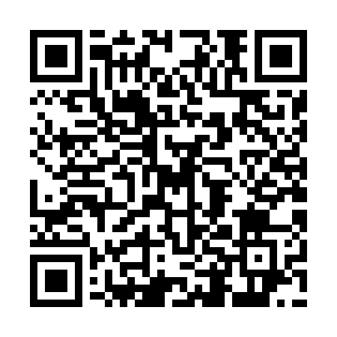
Prayer times for Las Palmas de Gran Canaria, Las Palmas, Spain
Wed 1 May 2024 - Fri 31 May 2024
High Latitude Method: Angle Based Rule
Prayer Calculation Method: Muslim World League
Asar Calculation Method: Hanafi

Date | Day | Fajr | Sunrise | Dhuhr | Asr | Maghrib | Isha
1 | Wed | 6:56 | 8:21 | 2:59 | 7:40 | 9:37 | 10:56
2 | Thu | 6:55 | 8:20 | 2:59 | 7:41 | 9:37 | 10:57
3 | Fri | 6:54 | 8:20 | 2:59 | 7:41 | 9:38 | 10:58
4 | Sat | 6:53 | 8:19 | 2:58 | 7:41 | 9:38 | 10:59
5 | Sun | 6:52 | 8:18 | 2:58 | 7:41 | 9:39 | 11:00
6 | Mon | 6:51 | 8:17 | 2:58 | 7:42 | 9:40 | 11:00
7 | Tue | 6:50 | 8:17 | 2:58 | 7:42 | 9:40 | 11:01
8 | Wed | 6:49 | 8:16 | 2:58 | 7:42 | 9:41 | 11:02
9 | Thu | 6:48 | 8:15 | 2:58 | 7:42 | 9:41 | 11:03
10 | Fri | 6:48 | 8:15 | 2:58 | 7:42 | 9:42 | 11:04
11 | Sat | 6:47 | 8:14 | 2:58 | 7:43 | 9:43 | 11:05
12 | Sun | 6:46 | 8:13 | 2:58 | 7:43 | 9:43 | 11:05
13 | Mon | 6:45 | 8:13 | 2:58 | 7:43 | 9:44 | 11:06
14 | Tue | 6:44 | 8:12 | 2:58 | 7:43 | 9:44 | 11:07
15 | Wed | 6:43 | 8:11 | 2:58 | 7:44 | 9:45 | 11:08
16 | Thu | 6:42 | 8:11 | 2:58 | 7:44 | 9:45 | 11:09
17 | Fri | 6:42 | 8:10 | 2:58 | 7:44 | 9:46 | 11:09
18 | Sat | 6:41 | 8:10 | 2:58 | 7:44 | 9:47 | 11:10
19 | Sun | 6:40 | 8:09 | 2:58 | 7:45 | 9:47 | 11:11
20 | Mon | 6:40 | 8:09 | 2:58 | 7:45 | 9:48 | 11:12
21 | Tue | 6:39 | 8:09 | 2:58 | 7:45 | 9:48 | 11:13
22 | Wed | 6:38 | 8:08 | 2:58 | 7:45 | 9:49 | 11:13
23 | Thu | 6:38 | 8:08 | 2:58 | 7:46 | 9:50 | 11:14
24 | Fri | 6:37 | 8:07 | 2:59 | 7:46 | 9:50 | 11:15
25 | Sat | 6:36 | 8:07 | 2:59 | 7:46 | 9:51 | 11:16
26 | Sun | 6:36 | 8:07 | 2:59 | 7:46 | 9:51 | 11:16
27 | Mon | 6:35 | 8:06 | 2:59 | 7:47 | 9:52 | 11:17
28 | Tue | 6:35 | 8:06 | 2:59 | 7:47 | 9:52 | 11:18
29 | Wed | 6:34 | 8:06 | 2:59 | 7:47 | 9:53 | 11:18
30 | Thu | 6:34 | 8:06 | 2:59 | 7:47 | 9:53 | 11:19
31 | Fri | 6:34 | 8:05 | 2:59 | 7:48 | 9:54 | 11:20
Prayer times provided by https://www.salahtimes.com

