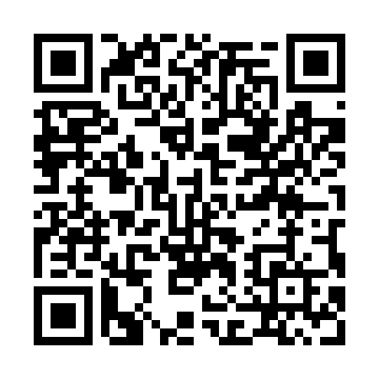
Prayer times for Al Hofuf, Saudi Arabia
Wed 1 May 2024 - Fri 31 May 2024
High Latitude Method: None
Prayer Calculation Method: Umm al-Qura, Makkah
Asar Calculation Method: Shafi

Date | Day | Fajr | Sunrise | Dhuhr | Asr | Maghrib | Isha
1 | Wed | 3:41 | 5:05 | 11:39 | 3:08 | 6:12 | 7:42
2 | Thu | 3:40 | 5:05 | 11:39 | 3:07 | 6:13 | 7:43
3 | Fri | 3:39 | 5:04 | 11:39 | 3:07 | 6:13 | 7:43
4 | Sat | 3:38 | 5:03 | 11:38 | 3:07 | 6:14 | 7:44
5 | Sun | 3:37 | 5:02 | 11:38 | 3:07 | 6:15 | 7:45
6 | Mon | 3:36 | 5:02 | 11:38 | 3:06 | 6:15 | 7:45
7 | Tue | 3:35 | 5:01 | 11:38 | 3:06 | 6:16 | 7:46
8 | Wed | 3:34 | 5:01 | 11:38 | 3:06 | 6:16 | 7:46
9 | Thu | 3:34 | 5:00 | 11:38 | 3:06 | 6:17 | 7:47
10 | Fri | 3:33 | 4:59 | 11:38 | 3:06 | 6:17 | 7:47
11 | Sat | 3:32 | 4:59 | 11:38 | 3:06 | 6:18 | 7:48
12 | Sun | 3:31 | 4:58 | 11:38 | 3:05 | 6:18 | 7:48
13 | Mon | 3:30 | 4:58 | 11:38 | 3:05 | 6:19 | 7:49
14 | Tue | 3:30 | 4:57 | 11:38 | 3:05 | 6:19 | 7:49
15 | Wed | 3:29 | 4:57 | 11:38 | 3:05 | 6:20 | 7:50
16 | Thu | 3:28 | 4:56 | 11:38 | 3:05 | 6:20 | 7:50
17 | Fri | 3:28 | 4:56 | 11:38 | 3:05 | 6:21 | 7:51
18 | Sat | 3:27 | 4:55 | 11:38 | 3:04 | 6:21 | 7:51
19 | Sun | 3:26 | 4:55 | 11:38 | 3:04 | 6:22 | 7:52
20 | Mon | 3:26 | 4:54 | 11:38 | 3:04 | 6:22 | 7:52
21 | Tue | 3:25 | 4:54 | 11:38 | 3:04 | 6:23 | 7:53
22 | Wed | 3:24 | 4:54 | 11:38 | 3:04 | 6:23 | 7:53
23 | Thu | 3:24 | 4:53 | 11:38 | 3:04 | 6:24 | 7:54
24 | Fri | 3:23 | 4:53 | 11:39 | 3:04 | 6:24 | 7:54
25 | Sat | 3:23 | 4:53 | 11:39 | 3:04 | 6:25 | 7:55
26 | Sun | 3:22 | 4:52 | 11:39 | 3:04 | 6:25 | 7:55
27 | Mon | 3:22 | 4:52 | 11:39 | 3:04 | 6:26 | 7:56
28 | Tue | 3:22 | 4:52 | 11:39 | 3:04 | 6:26 | 7:56
29 | Wed | 3:21 | 4:52 | 11:39 | 3:04 | 6:27 | 7:57
30 | Thu | 3:21 | 4:51 | 11:39 | 3:04 | 6:27 | 7:57
31 | Fri | 3:20 | 4:51 | 11:39 | 3:04 | 6:28 | 7:58
Prayer times provided by https://www.salahtimes.com

