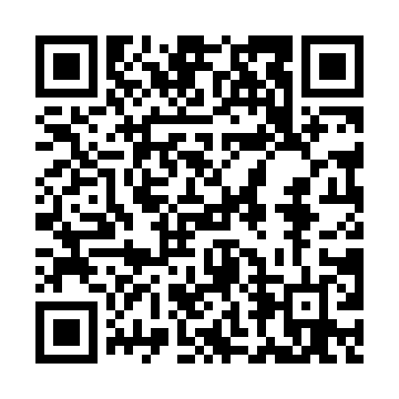
Prayer times for Banks Lake South, Washington, USA
Wed 1 May 2024 - Fri 31 May 2024
High Latitude Method: Angle Based Rule
Prayer Calculation Method: Islamic Society of North America
Asar Calculation Method: Shafi

Date | Day | Fajr | Sunrise | Dhuhr | Asr | Maghrib | Isha
1 | Wed | 3:57 | 5:39 | 12:54 | 4:53 | 8:10 | 9:53
2 | Thu | 3:55 | 5:37 | 12:54 | 4:54 | 8:12 | 9:55
3 | Fri | 3:52 | 5:36 | 12:54 | 4:54 | 8:13 | 9:57
4 | Sat | 3:50 | 5:34 | 12:54 | 4:55 | 8:14 | 9:59
5 | Sun | 3:48 | 5:33 | 12:54 | 4:55 | 8:16 | 10:01
6 | Mon | 3:46 | 5:31 | 12:54 | 4:56 | 8:17 | 10:03
7 | Tue | 3:43 | 5:30 | 12:54 | 4:56 | 8:18 | 10:05
8 | Wed | 3:41 | 5:28 | 12:54 | 4:57 | 8:20 | 10:07
9 | Thu | 3:39 | 5:27 | 12:54 | 4:57 | 8:21 | 10:09
10 | Fri | 3:37 | 5:25 | 12:53 | 4:58 | 8:22 | 10:11
11 | Sat | 3:35 | 5:24 | 12:53 | 4:58 | 8:24 | 10:13
12 | Sun | 3:33 | 5:23 | 12:53 | 4:59 | 8:25 | 10:15
13 | Mon | 3:31 | 5:21 | 12:53 | 4:59 | 8:26 | 10:17
14 | Tue | 3:29 | 5:20 | 12:53 | 5:00 | 8:28 | 10:19
15 | Wed | 3:27 | 5:19 | 12:53 | 5:00 | 8:29 | 10:22
16 | Thu | 3:25 | 5:18 | 12:54 | 5:01 | 8:30 | 10:24
17 | Fri | 3:23 | 5:16 | 12:54 | 5:01 | 8:31 | 10:26
18 | Sat | 3:21 | 5:15 | 12:54 | 5:02 | 8:33 | 10:28
19 | Sun | 3:19 | 5:14 | 12:54 | 5:02 | 8:34 | 10:30
20 | Mon | 3:17 | 5:13 | 12:54 | 5:03 | 8:35 | 10:32
21 | Tue | 3:15 | 5:12 | 12:54 | 5:03 | 8:36 | 10:34
22 | Wed | 3:13 | 5:11 | 12:54 | 5:04 | 8:37 | 10:36
23 | Thu | 3:11 | 5:10 | 12:54 | 5:04 | 8:38 | 10:38
24 | Fri | 3:10 | 5:09 | 12:54 | 5:04 | 8:40 | 10:40
25 | Sat | 3:08 | 5:08 | 12:54 | 5:05 | 8:41 | 10:41
26 | Sun | 3:06 | 5:07 | 12:54 | 5:05 | 8:42 | 10:43
27 | Mon | 3:05 | 5:06 | 12:54 | 5:06 | 8:43 | 10:45
28 | Tue | 3:03 | 5:06 | 12:55 | 5:06 | 8:44 | 10:47
29 | Wed | 3:01 | 5:05 | 12:55 | 5:06 | 8:45 | 10:49
30 | Thu | 3:00 | 5:04 | 12:55 | 5:07 | 8:46 | 10:50
31 | Fri | 2:59 | 5:04 | 12:55 | 5:07 | 8:47 | 10:51
Prayer times provided by https://www.salahtimes.com

