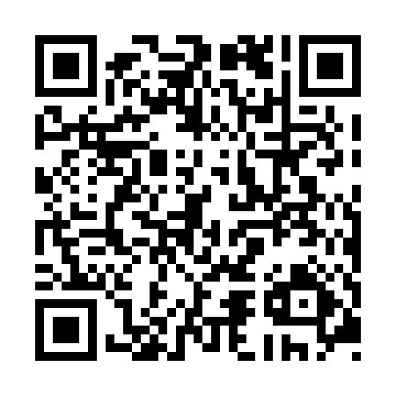
Prayer times for Trois-Ruisseaux, Quebec, Canada
Wed 1 May 2024 - Fri 31 May 2024
High Latitude Method: Angle Based Rule
Prayer Calculation Method: Islamic Society of North America
Asar Calculation Method: Hanafi

Date | Day | Fajr | Sunrise | Dhuhr | Asr | Maghrib | Isha
1 | Wed | 3:02 | 4:52 | 12:13 | 5:19 | 7:36 | 9:26
2 | Thu | 2:59 | 4:50 | 12:13 | 5:20 | 7:37 | 9:28
3 | Fri | 2:57 | 4:48 | 12:13 | 5:21 | 7:39 | 9:31
4 | Sat | 2:54 | 4:47 | 12:13 | 5:22 | 7:40 | 9:33
5 | Sun | 2:52 | 4:45 | 12:13 | 5:23 | 7:42 | 9:36
6 | Mon | 2:49 | 4:43 | 12:13 | 5:24 | 7:43 | 9:38
7 | Tue | 2:46 | 4:42 | 12:13 | 5:25 | 7:45 | 9:41
8 | Wed | 2:44 | 4:40 | 12:13 | 5:25 | 7:46 | 9:43
9 | Thu | 2:41 | 4:39 | 12:13 | 5:26 | 7:48 | 9:46
10 | Fri | 2:39 | 4:37 | 12:13 | 5:27 | 7:49 | 9:48
11 | Sat | 2:36 | 4:36 | 12:13 | 5:28 | 7:51 | 9:51
12 | Sun | 2:34 | 4:34 | 12:13 | 5:29 | 7:52 | 9:53
13 | Mon | 2:31 | 4:33 | 12:13 | 5:30 | 7:53 | 9:56
14 | Tue | 2:29 | 4:31 | 12:13 | 5:31 | 7:55 | 9:58
15 | Wed | 2:26 | 4:30 | 12:13 | 5:31 | 7:56 | 10:01
16 | Thu | 2:24 | 4:28 | 12:13 | 5:32 | 7:58 | 10:03
17 | Fri | 2:21 | 4:27 | 12:13 | 5:33 | 7:59 | 10:06
18 | Sat | 2:20 | 4:26 | 12:13 | 5:34 | 8:00 | 10:07
19 | Sun | 2:19 | 4:25 | 12:13 | 5:35 | 8:02 | 10:07
20 | Mon | 2:18 | 4:23 | 12:13 | 5:35 | 8:03 | 10:08
21 | Tue | 2:18 | 4:22 | 12:13 | 5:36 | 8:04 | 10:09
22 | Wed | 2:17 | 4:21 | 12:13 | 5:37 | 8:06 | 10:09
23 | Thu | 2:17 | 4:20 | 12:13 | 5:38 | 8:07 | 10:10
24 | Fri | 2:16 | 4:19 | 12:13 | 5:38 | 8:08 | 10:11
25 | Sat | 2:16 | 4:18 | 12:13 | 5:39 | 8:09 | 10:11
26 | Sun | 2:15 | 4:17 | 12:13 | 5:40 | 8:10 | 10:12
27 | Mon | 2:15 | 4:16 | 12:14 | 5:41 | 8:12 | 10:13
28 | Tue | 2:15 | 4:15 | 12:14 | 5:41 | 8:13 | 10:13
29 | Wed | 2:14 | 4:14 | 12:14 | 5:42 | 8:14 | 10:14
30 | Thu | 2:14 | 4:14 | 12:14 | 5:43 | 8:15 | 10:15
31 | Fri | 2:14 | 4:13 | 12:14 | 5:43 | 8:16 | 10:15
Prayer times provided by https://www.salahtimes.com

