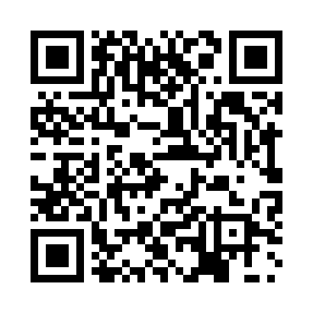
Prayer times for Bernister, Belgium
Wed 1 May 2024 - Fri 31 May 2024
High Latitude Method: Angle Based Rule
Prayer Calculation Method: Muslim World League
Asar Calculation Method: Shafi

Date | Day | Fajr | Sunrise | Dhuhr | Asr | Maghrib | Isha
1 | Wed | 3:48 | 6:10 | 1:33 | 5:35 | 8:57 | 11:09
2 | Thu | 3:45 | 6:09 | 1:33 | 5:36 | 8:58 | 11:12
3 | Fri | 3:41 | 6:07 | 1:33 | 5:36 | 9:00 | 11:15
4 | Sat | 3:38 | 6:05 | 1:33 | 5:37 | 9:01 | 11:18
5 | Sun | 3:35 | 6:03 | 1:33 | 5:37 | 9:03 | 11:20
6 | Mon | 3:31 | 6:02 | 1:33 | 5:38 | 9:04 | 11:23
7 | Tue | 3:28 | 6:00 | 1:32 | 5:39 | 9:06 | 11:26
8 | Wed | 3:24 | 5:58 | 1:32 | 5:39 | 9:07 | 11:29
9 | Thu | 3:21 | 5:57 | 1:32 | 5:40 | 9:09 | 11:32
10 | Fri | 3:18 | 5:55 | 1:32 | 5:40 | 9:10 | 11:36
11 | Sat | 3:17 | 5:54 | 1:32 | 5:41 | 9:12 | 11:39
12 | Sun | 3:16 | 5:52 | 1:32 | 5:42 | 9:13 | 11:40
13 | Mon | 3:16 | 5:51 | 1:32 | 5:42 | 9:15 | 11:41
14 | Tue | 3:15 | 5:49 | 1:32 | 5:43 | 9:16 | 11:42
15 | Wed | 3:15 | 5:48 | 1:32 | 5:43 | 9:18 | 11:42
16 | Thu | 3:14 | 5:46 | 1:32 | 5:44 | 9:19 | 11:43
17 | Fri | 3:14 | 5:45 | 1:32 | 5:44 | 9:20 | 11:43
18 | Sat | 3:13 | 5:44 | 1:32 | 5:45 | 9:22 | 11:44
19 | Sun | 3:13 | 5:42 | 1:32 | 5:45 | 9:23 | 11:45
20 | Mon | 3:12 | 5:41 | 1:33 | 5:46 | 9:25 | 11:45
21 | Tue | 3:12 | 5:40 | 1:33 | 5:46 | 9:26 | 11:46
22 | Wed | 3:11 | 5:39 | 1:33 | 5:47 | 9:27 | 11:46
23 | Thu | 3:11 | 5:38 | 1:33 | 5:47 | 9:28 | 11:47
24 | Fri | 3:11 | 5:37 | 1:33 | 5:48 | 9:30 | 11:48
25 | Sat | 3:10 | 5:36 | 1:33 | 5:48 | 9:31 | 11:48
26 | Sun | 3:10 | 5:35 | 1:33 | 5:49 | 9:32 | 11:49
27 | Mon | 3:10 | 5:34 | 1:33 | 5:49 | 9:33 | 11:49
28 | Tue | 3:09 | 5:33 | 1:33 | 5:50 | 9:34 | 11:50
29 | Wed | 3:09 | 5:32 | 1:33 | 5:50 | 9:36 | 11:51
30 | Thu | 3:09 | 5:31 | 1:34 | 5:51 | 9:37 | 11:51
31 | Fri | 3:08 | 5:30 | 1:34 | 5:51 | 9:38 | 11:52
Prayer times provided by https://www.salahtimes.com

