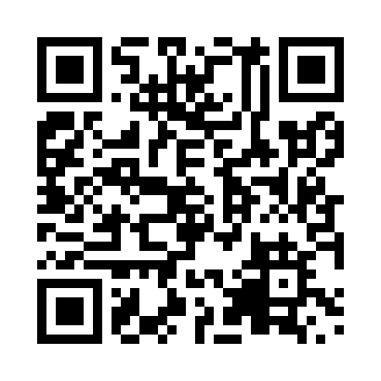
Prayer times for Jonquiere, Quebec, Canada
Mon 1 Jul 2024 - Wed 31 Jul 2024
High Latitude Method: Angle Based Rule
Prayer Calculation Method: Islamic Society of North America
Asar Calculation Method: Hanafi

Date | Day | Fajr | Sunrise | Dhuhr | Asr | Maghrib | Isha
1 | Mon | 2:48 | 4:48 | 12:49 | 6:18 | 8:50 | 10:49
2 | Tue | 2:49 | 4:49 | 12:49 | 6:18 | 8:49 | 10:49
3 | Wed | 2:49 | 4:49 | 12:49 | 6:18 | 8:49 | 10:49
4 | Thu | 2:50 | 4:50 | 12:50 | 6:18 | 8:49 | 10:49
5 | Fri | 2:50 | 4:51 | 12:50 | 6:18 | 8:48 | 10:49
6 | Sat | 2:51 | 4:52 | 12:50 | 6:18 | 8:48 | 10:49
7 | Sun | 2:51 | 4:53 | 12:50 | 6:17 | 8:47 | 10:49
8 | Mon | 2:52 | 4:53 | 12:50 | 6:17 | 8:47 | 10:48
9 | Tue | 2:52 | 4:54 | 12:50 | 6:17 | 8:46 | 10:48
10 | Wed | 2:53 | 4:55 | 12:50 | 6:17 | 8:45 | 10:48
11 | Thu | 2:53 | 4:56 | 12:51 | 6:16 | 8:45 | 10:48
12 | Fri | 2:54 | 4:57 | 12:51 | 6:16 | 8:44 | 10:47
13 | Sat | 2:54 | 4:58 | 12:51 | 6:16 | 8:43 | 10:47
14 | Sun | 2:55 | 4:59 | 12:51 | 6:15 | 8:42 | 10:47
15 | Mon | 2:55 | 5:00 | 12:51 | 6:15 | 8:41 | 10:46
16 | Tue | 2:56 | 5:01 | 12:51 | 6:14 | 8:41 | 10:46
17 | Wed | 2:57 | 5:02 | 12:51 | 6:14 | 8:40 | 10:44
18 | Thu | 2:59 | 5:03 | 12:51 | 6:13 | 8:39 | 10:42
19 | Fri | 3:01 | 5:05 | 12:51 | 6:13 | 8:38 | 10:40
20 | Sat | 3:04 | 5:06 | 12:51 | 6:12 | 8:37 | 10:38
21 | Sun | 3:06 | 5:07 | 12:51 | 6:12 | 8:36 | 10:36
22 | Mon | 3:08 | 5:08 | 12:51 | 6:11 | 8:34 | 10:34
23 | Tue | 3:10 | 5:09 | 12:52 | 6:10 | 8:33 | 10:32
24 | Wed | 3:12 | 5:10 | 12:52 | 6:10 | 8:32 | 10:30
25 | Thu | 3:14 | 5:12 | 12:52 | 6:09 | 8:31 | 10:28
26 | Fri | 3:16 | 5:13 | 12:52 | 6:08 | 8:30 | 10:26
27 | Sat | 3:18 | 5:14 | 12:52 | 6:07 | 8:28 | 10:24
28 | Sun | 3:21 | 5:15 | 12:51 | 6:07 | 8:27 | 10:21
29 | Mon | 3:23 | 5:17 | 12:51 | 6:06 | 8:26 | 10:19
30 | Tue | 3:25 | 5:18 | 12:51 | 6:05 | 8:24 | 10:17
31 | Wed | 3:27 | 5:19 | 12:51 | 6:04 | 8:23 | 10:15
Prayer times provided by https://www.salahtimes.com

