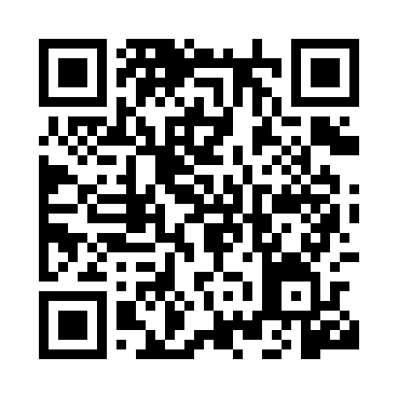
Prayer times for Ilva Mare, Romania
Wed 1 May 2024 - Fri 31 May 2024
High Latitude Method: Angle Based Rule
Prayer Calculation Method: Muslim World League
Asar Calculation Method: Hanafi

Date | Day | Fajr | Sunrise | Dhuhr | Asr | Maghrib | Isha
1 | Wed | 3:57 | 6:03 | 1:17 | 6:20 | 8:32 | 10:30
2 | Thu | 3:54 | 6:02 | 1:17 | 6:21 | 8:34 | 10:33
3 | Fri | 3:52 | 6:00 | 1:17 | 6:22 | 8:35 | 10:35
4 | Sat | 3:49 | 5:59 | 1:17 | 6:23 | 8:36 | 10:37
5 | Sun | 3:47 | 5:57 | 1:17 | 6:23 | 8:38 | 10:39
6 | Mon | 3:44 | 5:56 | 1:17 | 6:24 | 8:39 | 10:42
7 | Tue | 3:42 | 5:54 | 1:17 | 6:25 | 8:40 | 10:44
8 | Wed | 3:39 | 5:53 | 1:17 | 6:26 | 8:42 | 10:46
9 | Thu | 3:36 | 5:51 | 1:17 | 6:27 | 8:43 | 10:48
10 | Fri | 3:34 | 5:50 | 1:17 | 6:27 | 8:44 | 10:51
11 | Sat | 3:31 | 5:49 | 1:17 | 6:28 | 8:46 | 10:53
12 | Sun | 3:29 | 5:47 | 1:17 | 6:29 | 8:47 | 10:55
13 | Mon | 3:26 | 5:46 | 1:17 | 6:30 | 8:48 | 10:58
14 | Tue | 3:24 | 5:45 | 1:17 | 6:30 | 8:49 | 11:00
15 | Wed | 3:21 | 5:43 | 1:17 | 6:31 | 8:51 | 11:02
16 | Thu | 3:19 | 5:42 | 1:17 | 6:32 | 8:52 | 11:05
17 | Fri | 3:16 | 5:41 | 1:17 | 6:33 | 8:53 | 11:07
18 | Sat | 3:14 | 5:40 | 1:17 | 6:33 | 8:54 | 11:09
19 | Sun | 3:12 | 5:39 | 1:17 | 6:34 | 8:56 | 11:12
20 | Mon | 3:09 | 5:38 | 1:17 | 6:35 | 8:57 | 11:14
21 | Tue | 3:07 | 5:37 | 1:17 | 6:36 | 8:58 | 11:16
22 | Wed | 3:04 | 5:36 | 1:17 | 6:36 | 8:59 | 11:18
23 | Thu | 3:02 | 5:35 | 1:17 | 6:37 | 9:00 | 11:21
24 | Fri | 3:00 | 5:34 | 1:17 | 6:38 | 9:01 | 11:23
25 | Sat | 3:00 | 5:33 | 1:17 | 6:38 | 9:02 | 11:25
26 | Sun | 2:59 | 5:32 | 1:18 | 6:39 | 9:04 | 11:27
27 | Mon | 2:59 | 5:31 | 1:18 | 6:39 | 9:05 | 11:28
28 | Tue | 2:59 | 5:30 | 1:18 | 6:40 | 9:06 | 11:29
29 | Wed | 2:59 | 5:30 | 1:18 | 6:41 | 9:07 | 11:29
30 | Thu | 2:58 | 5:29 | 1:18 | 6:41 | 9:08 | 11:30
31 | Fri | 2:58 | 5:28 | 1:18 | 6:42 | 9:09 | 11:30
Prayer times provided by https://www.salahtimes.com

