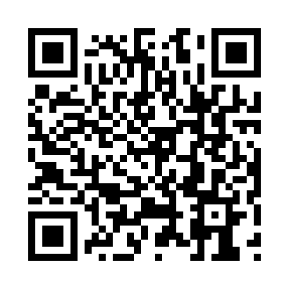
Prayer times for Deception, Quebec, Canada
Wed 1 May 2024 - Fri 31 May 2024
High Latitude Method: Angle Based Rule
Prayer Calculation Method: Islamic Society of North America
Asar Calculation Method: Hanafi

Date | Day | Fajr | Sunrise | Dhuhr | Asr | Maghrib | Isha
1 | Wed | 2:49 | 4:42 | 12:56 | 6:17 | 9:10 | 11:03
2 | Thu | 2:48 | 4:39 | 12:55 | 6:18 | 9:13 | 11:05
3 | Fri | 2:46 | 4:36 | 12:55 | 6:20 | 9:16 | 11:06
4 | Sat | 2:45 | 4:33 | 12:55 | 6:21 | 9:19 | 11:07
5 | Sun | 2:43 | 4:30 | 12:55 | 6:23 | 9:21 | 11:09
6 | Mon | 2:42 | 4:27 | 12:55 | 6:25 | 9:24 | 11:10
7 | Tue | 2:40 | 4:24 | 12:55 | 6:26 | 9:27 | 11:11
8 | Wed | 2:39 | 4:22 | 12:55 | 6:28 | 9:30 | 11:13
9 | Thu | 2:37 | 4:19 | 12:55 | 6:29 | 9:33 | 11:14
10 | Fri | 2:36 | 4:16 | 12:55 | 6:31 | 9:35 | 11:16
11 | Sat | 2:34 | 4:13 | 12:55 | 6:32 | 9:38 | 11:17
12 | Sun | 2:33 | 4:10 | 12:55 | 6:33 | 9:41 | 11:18
13 | Mon | 2:31 | 4:07 | 12:55 | 6:35 | 9:44 | 11:20
14 | Tue | 2:30 | 4:05 | 12:55 | 6:36 | 9:46 | 11:21
15 | Wed | 2:29 | 4:02 | 12:55 | 6:38 | 9:49 | 11:22
16 | Thu | 2:27 | 3:59 | 12:55 | 6:39 | 9:52 | 11:24
17 | Fri | 2:26 | 3:57 | 12:55 | 6:40 | 9:55 | 11:25
18 | Sat | 2:25 | 3:54 | 12:55 | 6:42 | 9:57 | 11:26
19 | Sun | 2:24 | 3:51 | 12:55 | 6:43 | 10:00 | 11:28
20 | Mon | 2:22 | 3:49 | 12:55 | 6:44 | 10:03 | 11:29
21 | Tue | 2:21 | 3:46 | 12:55 | 6:45 | 10:05 | 11:30
22 | Wed | 2:20 | 3:44 | 12:55 | 6:47 | 10:08 | 11:32
23 | Thu | 2:19 | 3:42 | 12:55 | 6:48 | 10:10 | 11:33
24 | Fri | 2:18 | 3:39 | 12:55 | 6:49 | 10:13 | 11:34
25 | Sat | 2:17 | 3:37 | 12:56 | 6:50 | 10:15 | 11:36
26 | Sun | 2:16 | 3:35 | 12:56 | 6:51 | 10:18 | 11:37
27 | Mon | 2:14 | 3:33 | 12:56 | 6:52 | 10:20 | 11:38
28 | Tue | 2:13 | 3:31 | 12:56 | 6:53 | 10:22 | 11:39
29 | Wed | 2:13 | 3:28 | 12:56 | 6:54 | 10:25 | 11:41
30 | Thu | 2:12 | 3:27 | 12:56 | 6:55 | 10:27 | 11:42
31 | Fri | 2:11 | 3:25 | 12:56 | 6:56 | 10:29 | 11:43
Prayer times provided by https://www.salahtimes.com

