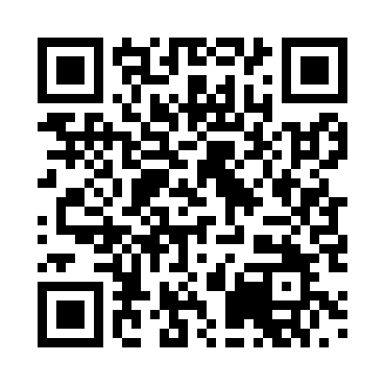
Prayer times for Trenkmoos, Germany
Wed 1 May 2024 - Fri 31 May 2024
High Latitude Method: Angle Based Rule
Prayer Calculation Method: Muslim World League
Asar Calculation Method: Shafi

Date | Day | Fajr | Sunrise | Dhuhr | Asr | Maghrib | Isha
1 | Wed | 3:42 | 5:51 | 1:06 | 5:06 | 8:23 | 10:23
2 | Thu | 3:39 | 5:49 | 1:06 | 5:06 | 8:24 | 10:25
3 | Fri | 3:37 | 5:48 | 1:06 | 5:07 | 8:25 | 10:28
4 | Sat | 3:34 | 5:46 | 1:06 | 5:07 | 8:27 | 10:30
5 | Sun | 3:31 | 5:45 | 1:06 | 5:08 | 8:28 | 10:32
6 | Mon | 3:29 | 5:43 | 1:06 | 5:08 | 8:30 | 10:35
7 | Tue | 3:26 | 5:42 | 1:06 | 5:09 | 8:31 | 10:37
8 | Wed | 3:24 | 5:40 | 1:06 | 5:09 | 8:32 | 10:39
9 | Thu | 3:21 | 5:39 | 1:06 | 5:10 | 8:34 | 10:42
10 | Fri | 3:18 | 5:37 | 1:06 | 5:10 | 8:35 | 10:44
11 | Sat | 3:16 | 5:36 | 1:06 | 5:11 | 8:36 | 10:47
12 | Sun | 3:13 | 5:34 | 1:06 | 5:11 | 8:38 | 10:49
13 | Mon | 3:10 | 5:33 | 1:06 | 5:12 | 8:39 | 10:51
14 | Tue | 3:08 | 5:32 | 1:06 | 5:12 | 8:40 | 10:54
15 | Wed | 3:05 | 5:31 | 1:06 | 5:13 | 8:42 | 10:56
16 | Thu | 3:02 | 5:29 | 1:06 | 5:13 | 8:43 | 10:59
17 | Fri | 3:00 | 5:28 | 1:06 | 5:14 | 8:44 | 11:01
18 | Sat | 2:57 | 5:27 | 1:06 | 5:14 | 8:45 | 11:04
19 | Sun | 2:55 | 5:26 | 1:06 | 5:15 | 8:47 | 11:06
20 | Mon | 2:52 | 5:25 | 1:06 | 5:15 | 8:48 | 11:08
21 | Tue | 2:49 | 5:24 | 1:06 | 5:16 | 8:49 | 11:11
22 | Wed | 2:49 | 5:23 | 1:06 | 5:16 | 8:50 | 11:13
23 | Thu | 2:49 | 5:22 | 1:06 | 5:17 | 8:51 | 11:16
24 | Fri | 2:48 | 5:21 | 1:06 | 5:17 | 8:52 | 11:16
25 | Sat | 2:48 | 5:20 | 1:06 | 5:17 | 8:54 | 11:17
26 | Sun | 2:48 | 5:19 | 1:07 | 5:18 | 8:55 | 11:18
27 | Mon | 2:47 | 5:18 | 1:07 | 5:18 | 8:56 | 11:18
28 | Tue | 2:47 | 5:17 | 1:07 | 5:19 | 8:57 | 11:19
29 | Wed | 2:47 | 5:16 | 1:07 | 5:19 | 8:58 | 11:19
30 | Thu | 2:47 | 5:16 | 1:07 | 5:20 | 8:59 | 11:20
31 | Fri | 2:46 | 5:15 | 1:07 | 5:20 | 9:00 | 11:20
Prayer times provided by https://www.salahtimes.com

