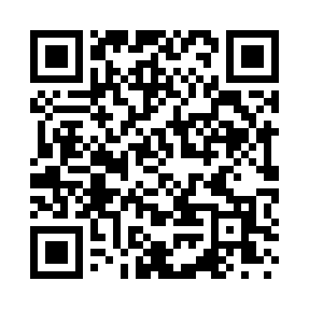
Prayer times for Eightmile Point, Utah, USA
Mon 1 Jul 2024 - Wed 31 Jul 2024
High Latitude Method: Angle Based Rule
Prayer Calculation Method: Islamic Society of North America
Asar Calculation Method: Shafi

Date | Day | Fajr | Sunrise | Dhuhr | Asr | Maghrib | Isha
1 | Mon | 4:36 | 6:09 | 1:34 | 5:30 | 8:59 | 10:32
2 | Tue | 4:36 | 6:10 | 1:34 | 5:30 | 8:59 | 10:32
3 | Wed | 4:37 | 6:10 | 1:35 | 5:30 | 8:59 | 10:32
4 | Thu | 4:38 | 6:11 | 1:35 | 5:30 | 8:58 | 10:31
5 | Fri | 4:39 | 6:12 | 1:35 | 5:31 | 8:58 | 10:31
6 | Sat | 4:39 | 6:12 | 1:35 | 5:31 | 8:58 | 10:31
7 | Sun | 4:40 | 6:13 | 1:35 | 5:31 | 8:58 | 10:30
8 | Mon | 4:41 | 6:13 | 1:35 | 5:31 | 8:57 | 10:29
9 | Tue | 4:42 | 6:14 | 1:36 | 5:31 | 8:57 | 10:29
10 | Wed | 4:43 | 6:15 | 1:36 | 5:31 | 8:57 | 10:28
11 | Thu | 4:44 | 6:15 | 1:36 | 5:31 | 8:56 | 10:27
12 | Fri | 4:45 | 6:16 | 1:36 | 5:31 | 8:56 | 10:27
13 | Sat | 4:46 | 6:17 | 1:36 | 5:31 | 8:55 | 10:26
14 | Sun | 4:47 | 6:17 | 1:36 | 5:31 | 8:55 | 10:25
15 | Mon | 4:48 | 6:18 | 1:36 | 5:31 | 8:54 | 10:24
16 | Tue | 4:49 | 6:19 | 1:36 | 5:31 | 8:54 | 10:23
17 | Wed | 4:50 | 6:20 | 1:36 | 5:31 | 8:53 | 10:23
18 | Thu | 4:51 | 6:20 | 1:37 | 5:31 | 8:52 | 10:22
19 | Fri | 4:52 | 6:21 | 1:37 | 5:31 | 8:52 | 10:21
20 | Sat | 4:53 | 6:22 | 1:37 | 5:31 | 8:51 | 10:20
21 | Sun | 4:54 | 6:23 | 1:37 | 5:30 | 8:50 | 10:19
22 | Mon | 4:55 | 6:24 | 1:37 | 5:30 | 8:49 | 10:17
23 | Tue | 4:56 | 6:24 | 1:37 | 5:30 | 8:49 | 10:16
24 | Wed | 4:58 | 6:25 | 1:37 | 5:30 | 8:48 | 10:15
25 | Thu | 4:59 | 6:26 | 1:37 | 5:30 | 8:47 | 10:14
26 | Fri | 5:00 | 6:27 | 1:37 | 5:30 | 8:46 | 10:13
27 | Sat | 5:01 | 6:28 | 1:37 | 5:29 | 8:45 | 10:12
28 | Sun | 5:02 | 6:29 | 1:37 | 5:29 | 8:44 | 10:10
29 | Mon | 5:04 | 6:30 | 1:37 | 5:29 | 8:43 | 10:09
30 | Tue | 5:05 | 6:30 | 1:37 | 5:29 | 8:42 | 10:08
31 | Wed | 5:06 | 6:31 | 1:37 | 5:28 | 8:41 | 10:06
Prayer times provided by https://www.salahtimes.com

