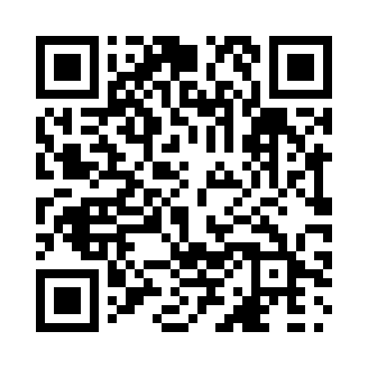
Prayer times for Welby, Saskatchewan, Canada
Mon 1 Jul 2024 - Wed 31 Jul 2024
High Latitude Method: Angle Based Rule
Prayer Calculation Method: Islamic Society of North America
Asar Calculation Method: Hanafi

Date | Day | Fajr | Sunrise | Dhuhr | Asr | Maghrib | Isha
1 | Mon | 2:45 | 4:39 | 12:50 | 6:24 | 9:01 | 10:56
2 | Tue | 2:45 | 4:40 | 12:51 | 6:24 | 9:01 | 10:56
3 | Wed | 2:46 | 4:41 | 12:51 | 6:24 | 9:00 | 10:56
4 | Thu | 2:46 | 4:41 | 12:51 | 6:24 | 9:00 | 10:55
5 | Fri | 2:47 | 4:42 | 12:51 | 6:24 | 9:00 | 10:55
6 | Sat | 2:47 | 4:43 | 12:51 | 6:23 | 8:59 | 10:55
7 | Sun | 2:48 | 4:44 | 12:51 | 6:23 | 8:58 | 10:55
8 | Mon | 2:48 | 4:45 | 12:52 | 6:23 | 8:58 | 10:55
9 | Tue | 2:49 | 4:46 | 12:52 | 6:23 | 8:57 | 10:54
10 | Wed | 2:49 | 4:47 | 12:52 | 6:22 | 8:56 | 10:54
11 | Thu | 2:50 | 4:48 | 12:52 | 6:22 | 8:56 | 10:54
12 | Fri | 2:50 | 4:49 | 12:52 | 6:21 | 8:55 | 10:53
13 | Sat | 2:51 | 4:50 | 12:52 | 6:21 | 8:54 | 10:53
14 | Sun | 2:52 | 4:51 | 12:52 | 6:21 | 8:53 | 10:52
15 | Mon | 2:52 | 4:52 | 12:52 | 6:20 | 8:52 | 10:52
16 | Tue | 2:53 | 4:53 | 12:52 | 6:20 | 8:51 | 10:52
17 | Wed | 2:53 | 4:55 | 12:53 | 6:19 | 8:50 | 10:51
18 | Thu | 2:54 | 4:56 | 12:53 | 6:18 | 8:49 | 10:51
19 | Fri | 2:55 | 4:57 | 12:53 | 6:18 | 8:48 | 10:50
20 | Sat | 2:55 | 4:58 | 12:53 | 6:17 | 8:46 | 10:49
21 | Sun | 2:56 | 5:00 | 12:53 | 6:17 | 8:45 | 10:49
22 | Mon | 2:57 | 5:01 | 12:53 | 6:16 | 8:44 | 10:48
23 | Tue | 2:57 | 5:02 | 12:53 | 6:15 | 8:43 | 10:48
24 | Wed | 2:58 | 5:04 | 12:53 | 6:14 | 8:41 | 10:47
25 | Thu | 2:59 | 5:05 | 12:53 | 6:14 | 8:40 | 10:46
26 | Fri | 2:59 | 5:06 | 12:53 | 6:13 | 8:39 | 10:46
27 | Sat | 3:00 | 5:08 | 12:53 | 6:12 | 8:37 | 10:44
28 | Sun | 3:03 | 5:09 | 12:53 | 6:11 | 8:36 | 10:41
29 | Mon | 3:05 | 5:10 | 12:53 | 6:10 | 8:34 | 10:39
30 | Tue | 3:08 | 5:12 | 12:53 | 6:09 | 8:33 | 10:36
31 | Wed | 3:11 | 5:13 | 12:53 | 6:08 | 8:31 | 10:33
Prayer times provided by https://www.salahtimes.com

