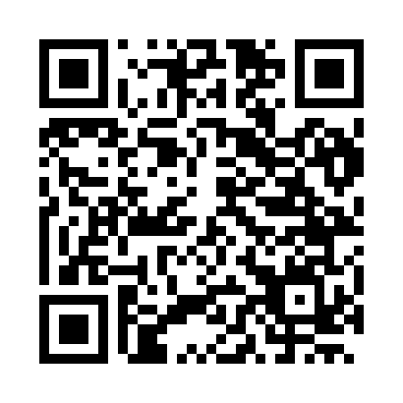
Prayer times for Loeuilly, France
Wed 1 May 2024 - Fri 31 May 2024
High Latitude Method: Angle Based Rule
Prayer Calculation Method: Islamic Organisations Union of France
Asar Calculation Method: Shafi

Date | Day | Fajr | Sunrise | Dhuhr | Asr | Maghrib | Isha
1 | Wed | 5:05 | 6:28 | 1:48 | 5:50 | 9:10 | 10:33
2 | Thu | 5:02 | 6:26 | 1:48 | 5:50 | 9:12 | 10:35
3 | Fri | 5:00 | 6:24 | 1:48 | 5:51 | 9:13 | 10:37
4 | Sat | 4:58 | 6:22 | 1:48 | 5:51 | 9:15 | 10:40
5 | Sun | 4:56 | 6:21 | 1:48 | 5:52 | 9:16 | 10:42
6 | Mon | 4:53 | 6:19 | 1:48 | 5:53 | 9:18 | 10:44
7 | Tue | 4:51 | 6:18 | 1:48 | 5:53 | 9:19 | 10:46
8 | Wed | 4:49 | 6:16 | 1:48 | 5:54 | 9:20 | 10:48
9 | Thu | 4:47 | 6:14 | 1:48 | 5:54 | 9:22 | 10:50
10 | Fri | 4:45 | 6:13 | 1:48 | 5:55 | 9:23 | 10:52
11 | Sat | 4:43 | 6:11 | 1:48 | 5:55 | 9:25 | 10:54
12 | Sun | 4:40 | 6:10 | 1:48 | 5:56 | 9:26 | 10:56
13 | Mon | 4:38 | 6:08 | 1:48 | 5:57 | 9:28 | 10:58
14 | Tue | 4:36 | 6:07 | 1:48 | 5:57 | 9:29 | 11:00
15 | Wed | 4:34 | 6:06 | 1:48 | 5:58 | 9:30 | 11:02
16 | Thu | 4:32 | 6:04 | 1:48 | 5:58 | 9:32 | 11:04
17 | Fri | 4:30 | 6:03 | 1:48 | 5:59 | 9:33 | 11:06
18 | Sat | 4:28 | 6:02 | 1:48 | 5:59 | 9:35 | 11:08
19 | Sun | 4:26 | 6:00 | 1:48 | 6:00 | 9:36 | 11:10
20 | Mon | 4:25 | 5:59 | 1:48 | 6:00 | 9:37 | 11:12
21 | Tue | 4:23 | 5:58 | 1:48 | 6:01 | 9:38 | 11:14
22 | Wed | 4:21 | 5:57 | 1:48 | 6:01 | 9:40 | 11:16
23 | Thu | 4:19 | 5:56 | 1:48 | 6:02 | 9:41 | 11:18
24 | Fri | 4:18 | 5:55 | 1:48 | 6:02 | 9:42 | 11:20
25 | Sat | 4:16 | 5:54 | 1:48 | 6:03 | 9:43 | 11:21
26 | Sun | 4:15 | 5:53 | 1:48 | 6:03 | 9:45 | 11:22
27 | Mon | 4:15 | 5:52 | 1:49 | 6:04 | 9:46 | 11:23
28 | Tue | 4:14 | 5:51 | 1:49 | 6:04 | 9:47 | 11:24
29 | Wed | 4:14 | 5:50 | 1:49 | 6:05 | 9:48 | 11:24
30 | Thu | 4:13 | 5:49 | 1:49 | 6:05 | 9:49 | 11:25
31 | Fri | 4:13 | 5:49 | 1:49 | 6:05 | 9:50 | 11:26
Prayer times provided by https://www.salahtimes.com

