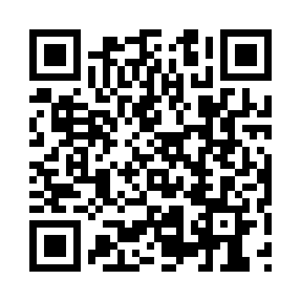
Prayer times for Towdystan, British Columbia, Canada
Wed 1 May 2024 - Fri 31 May 2024
High Latitude Method: Angle Based Rule
Prayer Calculation Method: Islamic Society of North America
Asar Calculation Method: Hanafi

Date | Day | Fajr | Sunrise | Dhuhr | Asr | Maghrib | Isha
1 | Wed | 3:48 | 5:48 | 1:17 | 6:26 | 8:47 | 10:49
2 | Thu | 3:45 | 5:46 | 1:17 | 6:27 | 8:49 | 10:52
3 | Fri | 3:41 | 5:44 | 1:17 | 6:28 | 8:51 | 10:54
4 | Sat | 3:38 | 5:43 | 1:17 | 6:29 | 8:52 | 10:57
5 | Sun | 3:35 | 5:41 | 1:17 | 6:30 | 8:54 | 11:00
6 | Mon | 3:32 | 5:39 | 1:17 | 6:31 | 8:56 | 11:03
7 | Tue | 3:29 | 5:37 | 1:17 | 6:32 | 8:57 | 11:06
8 | Wed | 3:26 | 5:35 | 1:17 | 6:33 | 8:59 | 11:08
9 | Thu | 3:25 | 5:34 | 1:17 | 6:34 | 9:01 | 11:09
10 | Fri | 3:25 | 5:32 | 1:17 | 6:35 | 9:02 | 11:10
11 | Sat | 3:24 | 5:30 | 1:17 | 6:36 | 9:04 | 11:10
12 | Sun | 3:23 | 5:29 | 1:17 | 6:37 | 9:05 | 11:11
13 | Mon | 3:22 | 5:27 | 1:17 | 6:38 | 9:07 | 11:12
14 | Tue | 3:21 | 5:26 | 1:17 | 6:39 | 9:09 | 11:13
15 | Wed | 3:21 | 5:24 | 1:17 | 6:40 | 9:10 | 11:14
16 | Thu | 3:20 | 5:23 | 1:17 | 6:40 | 9:12 | 11:14
17 | Fri | 3:19 | 5:21 | 1:17 | 6:41 | 9:13 | 11:15
18 | Sat | 3:18 | 5:20 | 1:17 | 6:42 | 9:15 | 11:16
19 | Sun | 3:18 | 5:18 | 1:17 | 6:43 | 9:16 | 11:17
20 | Mon | 3:17 | 5:17 | 1:17 | 6:44 | 9:18 | 11:17
21 | Tue | 3:17 | 5:16 | 1:17 | 6:45 | 9:19 | 11:18
22 | Wed | 3:16 | 5:14 | 1:17 | 6:46 | 9:20 | 11:19
23 | Thu | 3:15 | 5:13 | 1:17 | 6:46 | 9:22 | 11:20
24 | Fri | 3:15 | 5:12 | 1:17 | 6:47 | 9:23 | 11:20
25 | Sat | 3:14 | 5:11 | 1:17 | 6:48 | 9:24 | 11:21
26 | Sun | 3:14 | 5:10 | 1:17 | 6:49 | 9:26 | 11:22
27 | Mon | 3:13 | 5:09 | 1:18 | 6:49 | 9:27 | 11:22
28 | Tue | 3:13 | 5:08 | 1:18 | 6:50 | 9:28 | 11:23
29 | Wed | 3:12 | 5:07 | 1:18 | 6:51 | 9:29 | 11:24
30 | Thu | 3:12 | 5:06 | 1:18 | 6:52 | 9:31 | 11:24
31 | Fri | 3:12 | 5:05 | 1:18 | 6:52 | 9:32 | 11:25
Prayer times provided by https://www.salahtimes.com

