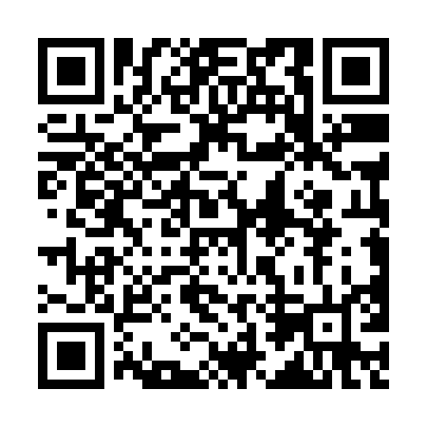
Prayer times for Loisy-en-Brie, France
Wed 1 May 2024 - Fri 31 May 2024
High Latitude Method: Angle Based Rule
Prayer Calculation Method: Islamic Organisations Union of France
Asar Calculation Method: Shafi

Date | Day | Fajr | Sunrise | Dhuhr | Asr | Maghrib | Isha
1 | Wed | 5:02 | 6:23 | 1:41 | 5:42 | 9:00 | 10:22
2 | Thu | 5:00 | 6:22 | 1:41 | 5:42 | 9:02 | 10:23
3 | Fri | 4:58 | 6:20 | 1:41 | 5:43 | 9:03 | 10:25
4 | Sat | 4:56 | 6:18 | 1:41 | 5:44 | 9:05 | 10:27
5 | Sun | 4:54 | 6:17 | 1:41 | 5:44 | 9:06 | 10:29
6 | Mon | 4:52 | 6:15 | 1:41 | 5:45 | 9:08 | 10:31
7 | Tue | 4:50 | 6:13 | 1:41 | 5:45 | 9:09 | 10:33
8 | Wed | 4:48 | 6:12 | 1:41 | 5:46 | 9:11 | 10:35
9 | Thu | 4:46 | 6:10 | 1:41 | 5:46 | 9:12 | 10:37
10 | Fri | 4:44 | 6:09 | 1:41 | 5:47 | 9:13 | 10:39
11 | Sat | 4:42 | 6:08 | 1:41 | 5:47 | 9:15 | 10:41
12 | Sun | 4:40 | 6:06 | 1:41 | 5:48 | 9:16 | 10:43
13 | Mon | 4:38 | 6:05 | 1:41 | 5:48 | 9:17 | 10:45
14 | Tue | 4:36 | 6:03 | 1:41 | 5:49 | 9:19 | 10:47
15 | Wed | 4:34 | 6:02 | 1:41 | 5:49 | 9:20 | 10:49
16 | Thu | 4:32 | 6:01 | 1:41 | 5:50 | 9:21 | 10:51
17 | Fri | 4:30 | 5:59 | 1:41 | 5:50 | 9:23 | 10:53
18 | Sat | 4:28 | 5:58 | 1:41 | 5:51 | 9:24 | 10:54
19 | Sun | 4:26 | 5:57 | 1:41 | 5:51 | 9:25 | 10:56
20 | Mon | 4:25 | 5:56 | 1:41 | 5:52 | 9:27 | 10:58
21 | Tue | 4:23 | 5:55 | 1:41 | 5:52 | 9:28 | 11:00
22 | Wed | 4:21 | 5:54 | 1:41 | 5:53 | 9:29 | 11:02
23 | Thu | 4:20 | 5:53 | 1:41 | 5:53 | 9:30 | 11:04
24 | Fri | 4:18 | 5:52 | 1:41 | 5:54 | 9:31 | 11:05
25 | Sat | 4:17 | 5:51 | 1:41 | 5:54 | 9:33 | 11:07
26 | Sun | 4:15 | 5:50 | 1:42 | 5:55 | 9:34 | 11:09
27 | Mon | 4:14 | 5:49 | 1:42 | 5:55 | 9:35 | 11:10
28 | Tue | 4:12 | 5:48 | 1:42 | 5:56 | 9:36 | 11:12
29 | Wed | 4:11 | 5:47 | 1:42 | 5:56 | 9:37 | 11:14
30 | Thu | 4:10 | 5:46 | 1:42 | 5:56 | 9:38 | 11:15
31 | Fri | 4:08 | 5:46 | 1:42 | 5:57 | 9:39 | 11:16
Prayer times provided by https://www.salahtimes.com

