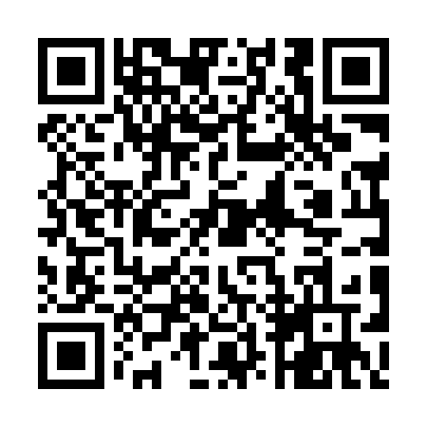
Prayer times for Cleversburg Junction, Pennsylvania, USA
Mon 1 Jul 2024 - Wed 31 Jul 2024
High Latitude Method: Angle Based Rule
Prayer Calculation Method: Islamic Society of North America
Asar Calculation Method: Shafi

Date | Day | Fajr | Sunrise | Dhuhr | Asr | Maghrib | Isha
1 | Mon | 4:08 | 5:45 | 1:14 | 5:12 | 8:43 | 10:20
2 | Tue | 4:09 | 5:45 | 1:14 | 5:13 | 8:43 | 10:19
3 | Wed | 4:09 | 5:46 | 1:14 | 5:13 | 8:42 | 10:19
4 | Thu | 4:10 | 5:47 | 1:14 | 5:13 | 8:42 | 10:18
5 | Fri | 4:11 | 5:47 | 1:15 | 5:13 | 8:42 | 10:18
6 | Sat | 4:12 | 5:48 | 1:15 | 5:13 | 8:42 | 10:17
7 | Sun | 4:13 | 5:48 | 1:15 | 5:13 | 8:41 | 10:17
8 | Mon | 4:13 | 5:49 | 1:15 | 5:13 | 8:41 | 10:16
9 | Tue | 4:14 | 5:50 | 1:15 | 5:13 | 8:41 | 10:16
10 | Wed | 4:15 | 5:50 | 1:15 | 5:13 | 8:40 | 10:15
11 | Thu | 4:16 | 5:51 | 1:15 | 5:13 | 8:40 | 10:14
12 | Fri | 4:17 | 5:52 | 1:16 | 5:13 | 8:39 | 10:13
13 | Sat | 4:18 | 5:52 | 1:16 | 5:13 | 8:39 | 10:13
14 | Sun | 4:19 | 5:53 | 1:16 | 5:13 | 8:38 | 10:12
15 | Mon | 4:21 | 5:54 | 1:16 | 5:13 | 8:38 | 10:11
16 | Tue | 4:22 | 5:55 | 1:16 | 5:13 | 8:37 | 10:10
17 | Wed | 4:23 | 5:56 | 1:16 | 5:13 | 8:36 | 10:09
18 | Thu | 4:24 | 5:56 | 1:16 | 5:13 | 8:36 | 10:08
19 | Fri | 4:25 | 5:57 | 1:16 | 5:13 | 8:35 | 10:07
20 | Sat | 4:26 | 5:58 | 1:16 | 5:13 | 8:34 | 10:06
21 | Sun | 4:27 | 5:59 | 1:16 | 5:12 | 8:33 | 10:05
22 | Mon | 4:29 | 6:00 | 1:16 | 5:12 | 8:33 | 10:03
23 | Tue | 4:30 | 6:01 | 1:16 | 5:12 | 8:32 | 10:02
24 | Wed | 4:31 | 6:01 | 1:16 | 5:12 | 8:31 | 10:01
25 | Thu | 4:32 | 6:02 | 1:16 | 5:12 | 8:30 | 10:00
26 | Fri | 4:34 | 6:03 | 1:16 | 5:11 | 8:29 | 9:59
27 | Sat | 4:35 | 6:04 | 1:16 | 5:11 | 8:28 | 9:57
28 | Sun | 4:36 | 6:05 | 1:16 | 5:11 | 8:27 | 9:56
29 | Mon | 4:37 | 6:06 | 1:16 | 5:11 | 8:26 | 9:55
30 | Tue | 4:39 | 6:07 | 1:16 | 5:10 | 8:25 | 9:53
31 | Wed | 4:40 | 6:08 | 1:16 | 5:10 | 8:24 | 9:52
Prayer times provided by https://www.salahtimes.com

