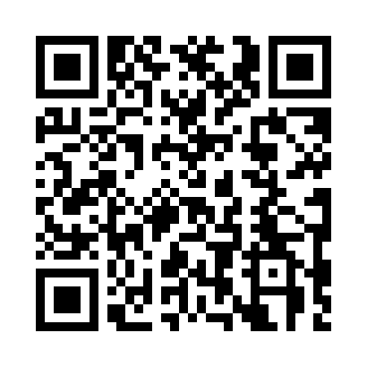
Prayer times for Uashatuess, Quebec, Canada
Wed 1 May 2024 - Fri 31 May 2024
High Latitude Method: Angle Based Rule
Prayer Calculation Method: Islamic Society of North America
Asar Calculation Method: Hanafi

Date | Day | Fajr | Sunrise | Dhuhr | Asr | Maghrib | Isha
1 | Wed | 3:05 | 5:00 | 12:25 | 5:32 | 7:51 | 9:46
2 | Thu | 3:03 | 4:58 | 12:25 | 5:33 | 7:52 | 9:48
3 | Fri | 3:00 | 4:56 | 12:25 | 5:34 | 7:54 | 9:51
4 | Sat | 2:57 | 4:54 | 12:24 | 5:35 | 7:55 | 9:54
5 | Sun | 2:54 | 4:53 | 12:24 | 5:36 | 7:57 | 9:56
6 | Mon | 2:51 | 4:51 | 12:24 | 5:37 | 7:58 | 9:59
7 | Tue | 2:48 | 4:49 | 12:24 | 5:37 | 8:00 | 10:02
8 | Wed | 2:46 | 4:48 | 12:24 | 5:38 | 8:02 | 10:04
9 | Thu | 2:43 | 4:46 | 12:24 | 5:39 | 8:03 | 10:07
10 | Fri | 2:40 | 4:44 | 12:24 | 5:40 | 8:05 | 10:10
11 | Sat | 2:37 | 4:43 | 12:24 | 5:41 | 8:06 | 10:12
12 | Sun | 2:34 | 4:41 | 12:24 | 5:42 | 8:08 | 10:15
13 | Mon | 2:32 | 4:40 | 12:24 | 5:43 | 8:09 | 10:17
14 | Tue | 2:31 | 4:38 | 12:24 | 5:44 | 8:11 | 10:18
15 | Wed | 2:31 | 4:37 | 12:24 | 5:45 | 8:12 | 10:18
16 | Thu | 2:30 | 4:35 | 12:24 | 5:46 | 8:14 | 10:19
17 | Fri | 2:29 | 4:34 | 12:24 | 5:46 | 8:15 | 10:20
18 | Sat | 2:29 | 4:33 | 12:24 | 5:47 | 8:16 | 10:20
19 | Sun | 2:28 | 4:31 | 12:24 | 5:48 | 8:18 | 10:21
20 | Mon | 2:27 | 4:30 | 12:24 | 5:49 | 8:19 | 10:22
21 | Tue | 2:27 | 4:29 | 12:24 | 5:50 | 8:21 | 10:23
22 | Wed | 2:26 | 4:28 | 12:24 | 5:50 | 8:22 | 10:23
23 | Thu | 2:26 | 4:27 | 12:25 | 5:51 | 8:23 | 10:24
24 | Fri | 2:25 | 4:25 | 12:25 | 5:52 | 8:24 | 10:25
25 | Sat | 2:25 | 4:24 | 12:25 | 5:53 | 8:26 | 10:25
26 | Sun | 2:24 | 4:23 | 12:25 | 5:53 | 8:27 | 10:26
27 | Mon | 2:24 | 4:22 | 12:25 | 5:54 | 8:28 | 10:27
28 | Tue | 2:23 | 4:21 | 12:25 | 5:55 | 8:29 | 10:27
29 | Wed | 2:23 | 4:21 | 12:25 | 5:56 | 8:30 | 10:28
30 | Thu | 2:23 | 4:20 | 12:25 | 5:56 | 8:32 | 10:29
31 | Fri | 2:22 | 4:19 | 12:26 | 5:57 | 8:33 | 10:29
Prayer times provided by https://www.salahtimes.com

