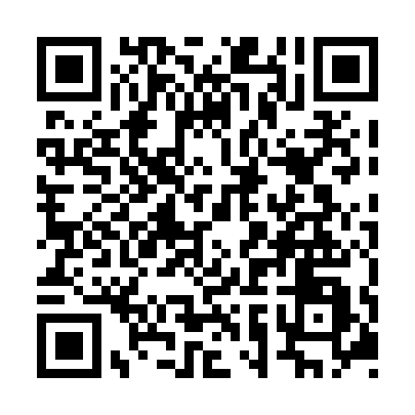
Prayer times for Admirals Beach, Newfoundland and Labrador, Canada
Wed 1 May 2024 - Fri 31 May 2024
High Latitude Method: Angle Based Rule
Prayer Calculation Method: Islamic Society of North America
Asar Calculation Method: Hanafi

Date | Day | Fajr | Sunrise | Dhuhr | Asr | Maghrib | Isha
1 | Wed | 4:08 | 5:48 | 1:01 | 6:04 | 8:16 | 9:56
2 | Thu | 4:06 | 5:46 | 1:01 | 6:05 | 8:17 | 9:58
3 | Fri | 4:04 | 5:45 | 1:01 | 6:06 | 8:18 | 10:00
4 | Sat | 4:02 | 5:43 | 1:01 | 6:06 | 8:20 | 10:02
5 | Sun | 3:59 | 5:42 | 1:01 | 6:07 | 8:21 | 10:04
6 | Mon | 3:57 | 5:40 | 1:01 | 6:08 | 8:22 | 10:06
7 | Tue | 3:55 | 5:39 | 1:01 | 6:09 | 8:24 | 10:08
8 | Wed | 3:53 | 5:37 | 1:01 | 6:10 | 8:25 | 10:10
9 | Thu | 3:51 | 5:36 | 1:01 | 6:10 | 8:26 | 10:12
10 | Fri | 3:49 | 5:35 | 1:01 | 6:11 | 8:28 | 10:14
11 | Sat | 3:47 | 5:33 | 1:01 | 6:12 | 8:29 | 10:16
12 | Sun | 3:45 | 5:32 | 1:01 | 6:13 | 8:30 | 10:18
13 | Mon | 3:43 | 5:31 | 1:01 | 6:13 | 8:31 | 10:20
14 | Tue | 3:41 | 5:30 | 1:01 | 6:14 | 8:33 | 10:22
15 | Wed | 3:39 | 5:28 | 1:01 | 6:15 | 8:34 | 10:24
16 | Thu | 3:37 | 5:27 | 1:01 | 6:16 | 8:35 | 10:26
17 | Fri | 3:35 | 5:26 | 1:01 | 6:16 | 8:36 | 10:28
18 | Sat | 3:33 | 5:25 | 1:01 | 6:17 | 8:37 | 10:30
19 | Sun | 3:31 | 5:24 | 1:01 | 6:18 | 8:39 | 10:32
20 | Mon | 3:30 | 5:23 | 1:01 | 6:18 | 8:40 | 10:33
21 | Tue | 3:28 | 5:22 | 1:01 | 6:19 | 8:41 | 10:35
22 | Wed | 3:26 | 5:21 | 1:01 | 6:20 | 8:42 | 10:37
23 | Thu | 3:24 | 5:20 | 1:01 | 6:20 | 8:43 | 10:39
24 | Fri | 3:23 | 5:19 | 1:01 | 6:21 | 8:44 | 10:41
25 | Sat | 3:21 | 5:18 | 1:01 | 6:22 | 8:45 | 10:43
26 | Sun | 3:19 | 5:17 | 1:02 | 6:22 | 8:46 | 10:44
27 | Mon | 3:18 | 5:16 | 1:02 | 6:23 | 8:47 | 10:46
28 | Tue | 3:16 | 5:16 | 1:02 | 6:24 | 8:48 | 10:48
29 | Wed | 3:15 | 5:15 | 1:02 | 6:24 | 8:49 | 10:50
30 | Thu | 3:14 | 5:14 | 1:02 | 6:25 | 8:50 | 10:51
31 | Fri | 3:12 | 5:13 | 1:02 | 6:25 | 8:51 | 10:53
Prayer times provided by https://www.salahtimes.com

