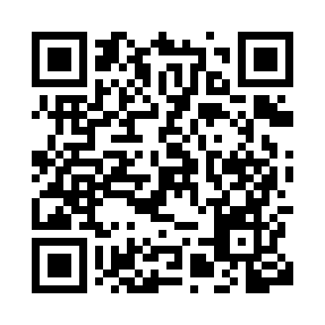
Prayer times for Silba, Croatia
Wed 1 May 2024 - Fri 31 May 2024
High Latitude Method: None
Prayer Calculation Method: Muslim World League
Asar Calculation Method: Shafi

Date | Day | Fajr | Sunrise | Dhuhr | Asr | Maghrib | Isha
1 | Wed | 3:56 | 5:52 | 12:58 | 4:54 | 8:06 | 9:54
2 | Thu | 3:54 | 5:50 | 12:58 | 4:54 | 8:07 | 9:56
3 | Fri | 3:52 | 5:49 | 12:58 | 4:55 | 8:08 | 9:57
4 | Sat | 3:50 | 5:47 | 12:58 | 4:55 | 8:09 | 9:59
5 | Sun | 3:48 | 5:46 | 12:58 | 4:56 | 8:11 | 10:01
6 | Mon | 3:46 | 5:45 | 12:58 | 4:56 | 8:12 | 10:03
7 | Tue | 3:44 | 5:43 | 12:58 | 4:56 | 8:13 | 10:05
8 | Wed | 3:41 | 5:42 | 12:58 | 4:57 | 8:14 | 10:07
9 | Thu | 3:39 | 5:41 | 12:58 | 4:57 | 8:15 | 10:09
10 | Fri | 3:37 | 5:40 | 12:58 | 4:57 | 8:16 | 10:10
11 | Sat | 3:35 | 5:38 | 12:58 | 4:58 | 8:18 | 10:12
12 | Sun | 3:33 | 5:37 | 12:58 | 4:58 | 8:19 | 10:14
13 | Mon | 3:31 | 5:36 | 12:58 | 4:59 | 8:20 | 10:16
14 | Tue | 3:30 | 5:35 | 12:58 | 4:59 | 8:21 | 10:18
15 | Wed | 3:28 | 5:34 | 12:58 | 4:59 | 8:22 | 10:20
16 | Thu | 3:26 | 5:33 | 12:58 | 5:00 | 8:23 | 10:21
17 | Fri | 3:24 | 5:32 | 12:58 | 5:00 | 8:24 | 10:23
18 | Sat | 3:22 | 5:31 | 12:58 | 5:00 | 8:25 | 10:25
19 | Sun | 3:20 | 5:30 | 12:58 | 5:01 | 8:26 | 10:27
20 | Mon | 3:18 | 5:29 | 12:58 | 5:01 | 8:27 | 10:29
21 | Tue | 3:17 | 5:28 | 12:58 | 5:02 | 8:29 | 10:30
22 | Wed | 3:15 | 5:27 | 12:58 | 5:02 | 8:30 | 10:32
23 | Thu | 3:13 | 5:26 | 12:58 | 5:02 | 8:31 | 10:34
24 | Fri | 3:12 | 5:25 | 12:58 | 5:03 | 8:32 | 10:35
25 | Sat | 3:10 | 5:24 | 12:58 | 5:03 | 8:33 | 10:37
26 | Sun | 3:08 | 5:24 | 12:58 | 5:03 | 8:33 | 10:39
27 | Mon | 3:07 | 5:23 | 12:58 | 5:04 | 8:34 | 10:40
28 | Tue | 3:05 | 5:22 | 12:59 | 5:04 | 8:35 | 10:42
29 | Wed | 3:04 | 5:22 | 12:59 | 5:04 | 8:36 | 10:44
30 | Thu | 3:03 | 5:21 | 12:59 | 5:05 | 8:37 | 10:45
31 | Fri | 3:01 | 5:20 | 12:59 | 5:05 | 8:38 | 10:47
Prayer times provided by https://www.salahtimes.com

