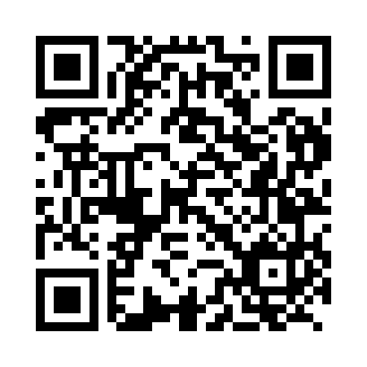
Prayer times for Kobilscak, Slovenia
Wed 1 May 2024 - Fri 31 May 2024
High Latitude Method: Angle Based Rule
Prayer Calculation Method: Muslim World League
Asar Calculation Method: Hanafi

Date | Day | Fajr | Sunrise | Dhuhr | Asr | Maghrib | Isha
1 | Wed | 3:37 | 5:41 | 12:53 | 5:55 | 8:06 | 10:01
2 | Thu | 3:35 | 5:39 | 12:53 | 5:56 | 8:07 | 10:03
3 | Fri | 3:32 | 5:38 | 12:53 | 5:56 | 8:09 | 10:06
4 | Sat | 3:30 | 5:36 | 12:53 | 5:57 | 8:10 | 10:08
5 | Sun | 3:27 | 5:35 | 12:53 | 5:58 | 8:11 | 10:10
6 | Mon | 3:25 | 5:33 | 12:52 | 5:59 | 8:12 | 10:12
7 | Tue | 3:23 | 5:32 | 12:52 | 6:00 | 8:14 | 10:14
8 | Wed | 3:20 | 5:30 | 12:52 | 6:00 | 8:15 | 10:16
9 | Thu | 3:18 | 5:29 | 12:52 | 6:01 | 8:16 | 10:18
10 | Fri | 3:16 | 5:28 | 12:52 | 6:02 | 8:18 | 10:21
11 | Sat | 3:13 | 5:26 | 12:52 | 6:03 | 8:19 | 10:23
12 | Sun | 3:11 | 5:25 | 12:52 | 6:03 | 8:20 | 10:25
13 | Mon | 3:08 | 5:24 | 12:52 | 6:04 | 8:21 | 10:27
14 | Tue | 3:06 | 5:23 | 12:52 | 6:05 | 8:23 | 10:29
15 | Wed | 3:04 | 5:21 | 12:52 | 6:06 | 8:24 | 10:31
16 | Thu | 3:02 | 5:20 | 12:52 | 6:06 | 8:25 | 10:34
17 | Fri | 2:59 | 5:19 | 12:52 | 6:07 | 8:26 | 10:36
18 | Sat | 2:57 | 5:18 | 12:52 | 6:08 | 8:27 | 10:38
19 | Sun | 2:55 | 5:17 | 12:52 | 6:08 | 8:29 | 10:40
20 | Mon | 2:53 | 5:16 | 12:52 | 6:09 | 8:30 | 10:42
21 | Tue | 2:50 | 5:15 | 12:53 | 6:10 | 8:31 | 10:44
22 | Wed | 2:48 | 5:14 | 12:53 | 6:10 | 8:32 | 10:46
23 | Thu | 2:46 | 5:13 | 12:53 | 6:11 | 8:33 | 10:49
24 | Fri | 2:44 | 5:12 | 12:53 | 6:12 | 8:34 | 10:51
25 | Sat | 2:42 | 5:11 | 12:53 | 6:12 | 8:35 | 10:53
26 | Sun | 2:40 | 5:10 | 12:53 | 6:13 | 8:36 | 10:55
27 | Mon | 2:38 | 5:09 | 12:53 | 6:14 | 8:37 | 10:57
28 | Tue | 2:36 | 5:09 | 12:53 | 6:14 | 8:38 | 10:59
29 | Wed | 2:35 | 5:08 | 12:53 | 6:15 | 8:39 | 11:01
30 | Thu | 2:35 | 5:07 | 12:54 | 6:15 | 8:40 | 11:02
31 | Fri | 2:35 | 5:07 | 12:54 | 6:16 | 8:41 | 11:04
Prayer times provided by https://www.salahtimes.com

