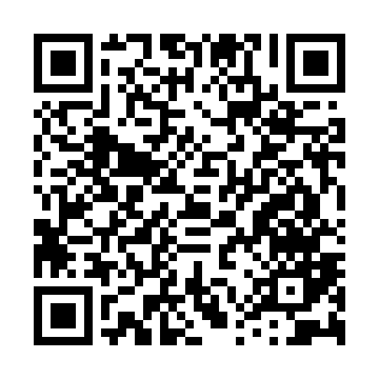
Prayer times for Country Club View, North Carolina, USA
Mon 1 Apr 2024 - Tue 30 Apr 2024
High Latitude Method: Angle Based Rule
Prayer Calculation Method: Islamic Society of North America
Asar Calculation Method: Shafi

Date | Day | Fajr | Sunrise | Dhuhr | Asr | Maghrib | Isha
1 | Mon | 5:49 | 7:00 | 1:18 | 4:52 | 7:37 | 8:48
2 | Tue | 5:47 | 6:59 | 1:18 | 4:52 | 7:37 | 8:49
3 | Wed | 5:45 | 6:57 | 1:17 | 4:53 | 7:38 | 8:50
4 | Thu | 5:44 | 6:56 | 1:17 | 4:53 | 7:39 | 8:51
5 | Fri | 5:42 | 6:54 | 1:17 | 4:53 | 7:40 | 8:52
6 | Sat | 5:41 | 6:53 | 1:17 | 4:53 | 7:41 | 8:53
7 | Sun | 5:39 | 6:52 | 1:16 | 4:53 | 7:42 | 8:54
8 | Mon | 5:38 | 6:50 | 1:16 | 4:54 | 7:42 | 8:55
9 | Tue | 5:36 | 6:49 | 1:16 | 4:54 | 7:43 | 8:56
10 | Wed | 5:35 | 6:47 | 1:15 | 4:54 | 7:44 | 8:57
11 | Thu | 5:33 | 6:46 | 1:15 | 4:54 | 7:45 | 8:58
12 | Fri | 5:32 | 6:45 | 1:15 | 4:54 | 7:46 | 8:59
13 | Sat | 5:30 | 6:43 | 1:15 | 4:54 | 7:47 | 9:00
14 | Sun | 5:29 | 6:42 | 1:14 | 4:54 | 7:47 | 9:01
15 | Mon | 5:27 | 6:41 | 1:14 | 4:55 | 7:48 | 9:02
16 | Tue | 5:25 | 6:39 | 1:14 | 4:55 | 7:49 | 9:03
17 | Wed | 5:24 | 6:38 | 1:14 | 4:55 | 7:50 | 9:04
18 | Thu | 5:23 | 6:37 | 1:14 | 4:55 | 7:51 | 9:05
19 | Fri | 5:21 | 6:36 | 1:13 | 4:55 | 7:52 | 9:06
20 | Sat | 5:20 | 6:34 | 1:13 | 4:55 | 7:52 | 9:07
21 | Sun | 5:18 | 6:33 | 1:13 | 4:55 | 7:53 | 9:09
22 | Mon | 5:17 | 6:32 | 1:13 | 4:56 | 7:54 | 9:10
23 | Tue | 5:15 | 6:31 | 1:13 | 4:56 | 7:55 | 9:11
24 | Wed | 5:14 | 6:30 | 1:12 | 4:56 | 7:56 | 9:12
25 | Thu | 5:12 | 6:28 | 1:12 | 4:56 | 7:57 | 9:13
26 | Fri | 5:11 | 6:27 | 1:12 | 4:56 | 7:57 | 9:14
27 | Sat | 5:09 | 6:26 | 1:12 | 4:56 | 7:58 | 9:15
28 | Sun | 5:08 | 6:25 | 1:12 | 4:56 | 7:59 | 9:16
29 | Mon | 5:07 | 6:24 | 1:12 | 4:56 | 8:00 | 9:17
30 | Tue | 5:05 | 6:23 | 1:12 | 4:56 | 8:01 | 9:18
Prayer times provided by https://www.salahtimes.com

