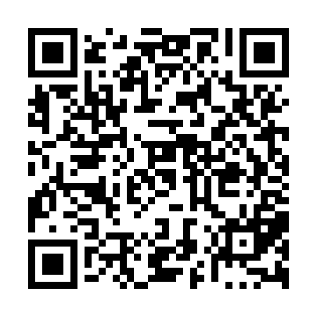
Prayer times for Tobique Narrows, New Brunswick, Canada
Mon 1 Apr 2024 - Tue 30 Apr 2024
High Latitude Method: Angle Based Rule
Prayer Calculation Method: Islamic Society of North America
Asar Calculation Method: Hanafi

Date | Day | Fajr | Sunrise | Dhuhr | Asr | Maghrib | Isha
1 | Mon | 5:43 | 7:09 | 1:34 | 6:03 | 8:01 | 9:27
2 | Tue | 5:40 | 7:07 | 1:34 | 6:04 | 8:02 | 9:29
3 | Wed | 5:38 | 7:05 | 1:34 | 6:05 | 8:03 | 9:30
4 | Thu | 5:36 | 7:03 | 1:34 | 6:06 | 8:05 | 9:32
5 | Fri | 5:34 | 7:01 | 1:33 | 6:07 | 8:06 | 9:34
6 | Sat | 5:32 | 6:59 | 1:33 | 6:08 | 8:08 | 9:36
7 | Sun | 5:29 | 6:57 | 1:33 | 6:09 | 8:09 | 9:37
8 | Mon | 5:27 | 6:55 | 1:32 | 6:10 | 8:10 | 9:39
9 | Tue | 5:25 | 6:54 | 1:32 | 6:11 | 8:12 | 9:41
10 | Wed | 5:23 | 6:52 | 1:32 | 6:12 | 8:13 | 9:42
11 | Thu | 5:20 | 6:50 | 1:32 | 6:13 | 8:14 | 9:44
12 | Fri | 5:18 | 6:48 | 1:31 | 6:14 | 8:16 | 9:46
13 | Sat | 5:16 | 6:46 | 1:31 | 6:15 | 8:17 | 9:48
14 | Sun | 5:13 | 6:44 | 1:31 | 6:16 | 8:18 | 9:49
15 | Mon | 5:11 | 6:42 | 1:31 | 6:17 | 8:20 | 9:51
16 | Tue | 5:09 | 6:40 | 1:30 | 6:17 | 8:21 | 9:53
17 | Wed | 5:07 | 6:39 | 1:30 | 6:18 | 8:23 | 9:55
18 | Thu | 5:04 | 6:37 | 1:30 | 6:19 | 8:24 | 9:57
19 | Fri | 5:02 | 6:35 | 1:30 | 6:20 | 8:25 | 9:58
20 | Sat | 5:00 | 6:33 | 1:30 | 6:21 | 8:27 | 10:00
21 | Sun | 4:58 | 6:31 | 1:29 | 6:22 | 8:28 | 10:02
22 | Mon | 4:55 | 6:30 | 1:29 | 6:23 | 8:29 | 10:04
23 | Tue | 4:53 | 6:28 | 1:29 | 6:23 | 8:31 | 10:06
24 | Wed | 4:51 | 6:26 | 1:29 | 6:24 | 8:32 | 10:08
25 | Thu | 4:49 | 6:25 | 1:29 | 6:25 | 8:33 | 10:10
26 | Fri | 4:47 | 6:23 | 1:28 | 6:26 | 8:35 | 10:11
27 | Sat | 4:44 | 6:21 | 1:28 | 6:27 | 8:36 | 10:13
28 | Sun | 4:42 | 6:20 | 1:28 | 6:28 | 8:37 | 10:15
29 | Mon | 4:40 | 6:18 | 1:28 | 6:28 | 8:39 | 10:17
30 | Tue | 4:38 | 6:16 | 1:28 | 6:29 | 8:40 | 10:19
Prayer times provided by https://www.salahtimes.com

