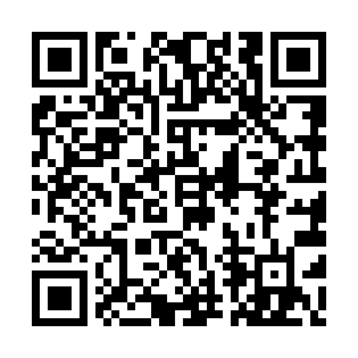
Prayer times for Burwash Landing, Yukon, Canada
Wed 1 May 2024 - Fri 31 May 2024
High Latitude Method: Angle Based Rule
Prayer Calculation Method: Islamic Society of North America
Asar Calculation Method: Hanafi

Date | Day | Fajr | Sunrise | Dhuhr | Asr | Maghrib | Isha
1 | Wed | 4:09 | 6:04 | 2:13 | 7:33 | 10:23 | 12:19
2 | Thu | 4:07 | 6:01 | 2:13 | 7:35 | 10:26 | 12:20
3 | Fri | 4:06 | 5:58 | 2:13 | 7:36 | 10:29 | 12:21
4 | Sat | 4:04 | 5:55 | 2:13 | 7:38 | 10:32 | 12:22
5 | Sun | 4:03 | 5:52 | 2:13 | 7:39 | 10:34 | 12:24
6 | Mon | 4:01 | 5:50 | 2:13 | 7:41 | 10:37 | 12:25
7 | Tue | 4:00 | 5:47 | 2:12 | 7:42 | 10:40 | 12:26
8 | Wed | 3:59 | 5:44 | 2:12 | 7:44 | 10:42 | 12:28
9 | Thu | 3:57 | 5:41 | 2:12 | 7:45 | 10:45 | 12:29
10 | Fri | 3:56 | 5:39 | 2:12 | 7:47 | 10:47 | 12:30
11 | Sat | 3:54 | 5:36 | 2:12 | 7:48 | 10:50 | 12:32
12 | Sun | 3:53 | 5:33 | 2:12 | 7:49 | 10:53 | 12:33
13 | Mon | 3:52 | 5:31 | 2:12 | 7:51 | 10:55 | 12:34
14 | Tue | 3:51 | 5:28 | 2:12 | 7:52 | 10:58 | 12:35
15 | Wed | 3:49 | 5:26 | 2:12 | 7:53 | 11:00 | 12:37
16 | Thu | 3:48 | 5:23 | 2:12 | 7:55 | 11:03 | 12:38
17 | Fri | 3:47 | 5:21 | 2:12 | 7:56 | 11:06 | 12:39
18 | Sat | 3:46 | 5:18 | 2:12 | 7:57 | 11:08 | 12:41
19 | Sun | 3:44 | 5:16 | 2:13 | 7:58 | 11:11 | 12:42
20 | Mon | 3:43 | 5:13 | 2:13 | 8:00 | 11:13 | 12:43
21 | Tue | 3:42 | 5:11 | 2:13 | 8:01 | 11:15 | 12:44
22 | Wed | 3:41 | 5:09 | 2:13 | 8:02 | 11:18 | 12:46
23 | Thu | 3:40 | 5:07 | 2:13 | 8:03 | 11:20 | 12:47
24 | Fri | 3:39 | 5:04 | 2:13 | 8:04 | 11:23 | 12:48
25 | Sat | 3:38 | 5:02 | 2:13 | 8:05 | 11:25 | 12:49
26 | Sun | 3:37 | 5:00 | 2:13 | 8:06 | 11:27 | 12:50
27 | Mon | 3:36 | 4:58 | 2:13 | 8:08 | 11:29 | 12:52
28 | Tue | 3:35 | 4:56 | 2:13 | 8:09 | 11:31 | 12:53
29 | Wed | 3:34 | 4:54 | 2:14 | 8:10 | 11:34 | 12:54
30 | Thu | 3:33 | 4:53 | 2:14 | 8:11 | 11:36 | 12:55
31 | Fri | 3:33 | 4:51 | 2:14 | 8:11 | 11:38 | 12:56
Prayer times provided by https://www.salahtimes.com

