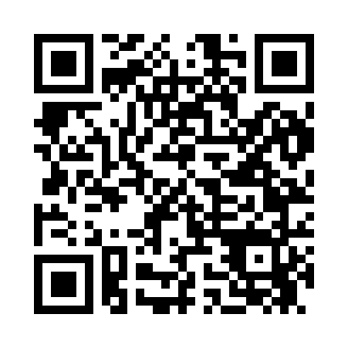
Prayer times for Alki, Washington, USA
Wed 1 May 2024 - Fri 31 May 2024
High Latitude Method: Angle Based Rule
Prayer Calculation Method: Islamic Society of North America
Asar Calculation Method: Shafi

Date | Day | Fajr | Sunrise | Dhuhr | Asr | Maghrib | Isha
1 | Wed | 4:10 | 5:51 | 1:07 | 5:06 | 8:23 | 10:05
2 | Thu | 4:07 | 5:50 | 1:07 | 5:06 | 8:24 | 10:07
3 | Fri | 4:05 | 5:48 | 1:06 | 5:07 | 8:25 | 10:09
4 | Sat | 4:03 | 5:47 | 1:06 | 5:07 | 8:27 | 10:11
5 | Sun | 4:01 | 5:45 | 1:06 | 5:08 | 8:28 | 10:13
6 | Mon | 3:59 | 5:44 | 1:06 | 5:08 | 8:29 | 10:15
7 | Tue | 3:56 | 5:42 | 1:06 | 5:09 | 8:31 | 10:17
8 | Wed | 3:54 | 5:41 | 1:06 | 5:09 | 8:32 | 10:19
9 | Thu | 3:52 | 5:39 | 1:06 | 5:10 | 8:33 | 10:21
10 | Fri | 3:50 | 5:38 | 1:06 | 5:10 | 8:35 | 10:23
11 | Sat | 3:48 | 5:37 | 1:06 | 5:11 | 8:36 | 10:25
12 | Sun | 3:46 | 5:35 | 1:06 | 5:11 | 8:37 | 10:27
13 | Mon | 3:44 | 5:34 | 1:06 | 5:12 | 8:39 | 10:30
14 | Tue | 3:42 | 5:33 | 1:06 | 5:12 | 8:40 | 10:32
15 | Wed | 3:40 | 5:31 | 1:06 | 5:13 | 8:41 | 10:34
16 | Thu | 3:38 | 5:30 | 1:06 | 5:13 | 8:42 | 10:36
17 | Fri | 3:36 | 5:29 | 1:06 | 5:14 | 8:44 | 10:38
18 | Sat | 3:34 | 5:28 | 1:06 | 5:14 | 8:45 | 10:40
19 | Sun | 3:32 | 5:27 | 1:06 | 5:15 | 8:46 | 10:42
20 | Mon | 3:30 | 5:26 | 1:06 | 5:15 | 8:47 | 10:44
21 | Tue | 3:28 | 5:25 | 1:06 | 5:16 | 8:48 | 10:46
22 | Wed | 3:26 | 5:24 | 1:06 | 5:16 | 8:50 | 10:48
23 | Thu | 3:24 | 5:23 | 1:06 | 5:16 | 8:51 | 10:50
24 | Fri | 3:23 | 5:22 | 1:07 | 5:17 | 8:52 | 10:52
25 | Sat | 3:21 | 5:21 | 1:07 | 5:17 | 8:53 | 10:53
26 | Sun | 3:19 | 5:20 | 1:07 | 5:18 | 8:54 | 10:55
27 | Mon | 3:18 | 5:19 | 1:07 | 5:18 | 8:55 | 10:57
28 | Tue | 3:16 | 5:18 | 1:07 | 5:19 | 8:56 | 10:59
29 | Wed | 3:15 | 5:18 | 1:07 | 5:19 | 8:57 | 11:01
30 | Thu | 3:13 | 5:17 | 1:07 | 5:19 | 8:58 | 11:02
31 | Fri | 3:12 | 5:16 | 1:07 | 5:20 | 8:59 | 11:03
Prayer times provided by https://www.salahtimes.com

