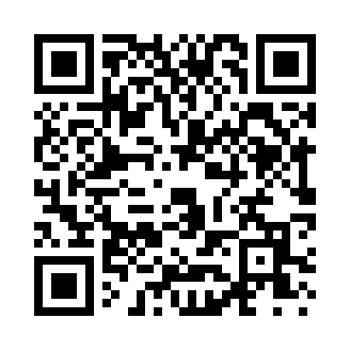
Prayer times for Carys Mills, Maine, USA
Mon 1 Jul 2024 - Wed 31 Jul 2024
High Latitude Method: Angle Based Rule
Prayer Calculation Method: Islamic Society of North America
Asar Calculation Method: Shafi

Date | Day | Fajr | Sunrise | Dhuhr | Asr | Maghrib | Isha
1 | Mon | 2:43 | 4:45 | 12:36 | 4:46 | 8:26 | 10:27
2 | Tue | 2:44 | 4:45 | 12:36 | 4:47 | 8:26 | 10:26
3 | Wed | 2:46 | 4:46 | 12:36 | 4:47 | 8:26 | 10:26
4 | Thu | 2:47 | 4:47 | 12:36 | 4:47 | 8:25 | 10:25
5 | Fri | 2:48 | 4:47 | 12:36 | 4:47 | 8:25 | 10:24
6 | Sat | 2:49 | 4:48 | 12:36 | 4:47 | 8:25 | 10:23
7 | Sun | 2:50 | 4:49 | 12:37 | 4:47 | 8:24 | 10:22
8 | Mon | 2:52 | 4:50 | 12:37 | 4:47 | 8:24 | 10:21
9 | Tue | 2:53 | 4:50 | 12:37 | 4:47 | 8:23 | 10:20
10 | Wed | 2:54 | 4:51 | 12:37 | 4:46 | 8:22 | 10:19
11 | Thu | 2:56 | 4:52 | 12:37 | 4:46 | 8:22 | 10:18
12 | Fri | 2:57 | 4:53 | 12:37 | 4:46 | 8:21 | 10:17
13 | Sat | 2:59 | 4:54 | 12:37 | 4:46 | 8:20 | 10:15
14 | Sun | 3:00 | 4:55 | 12:37 | 4:46 | 8:20 | 10:14
15 | Mon | 3:02 | 4:56 | 12:38 | 4:46 | 8:19 | 10:13
16 | Tue | 3:03 | 4:57 | 12:38 | 4:46 | 8:18 | 10:11
17 | Wed | 3:05 | 4:58 | 12:38 | 4:45 | 8:17 | 10:10
18 | Thu | 3:07 | 4:59 | 12:38 | 4:45 | 8:16 | 10:08
19 | Fri | 3:08 | 5:00 | 12:38 | 4:45 | 8:16 | 10:07
20 | Sat | 3:10 | 5:01 | 12:38 | 4:45 | 8:15 | 10:05
21 | Sun | 3:12 | 5:02 | 12:38 | 4:44 | 8:14 | 10:03
22 | Mon | 3:13 | 5:03 | 12:38 | 4:44 | 8:13 | 10:02
23 | Tue | 3:15 | 5:04 | 12:38 | 4:44 | 8:12 | 10:00
24 | Wed | 3:17 | 5:05 | 12:38 | 4:43 | 8:10 | 9:58
25 | Thu | 3:19 | 5:06 | 12:38 | 4:43 | 8:09 | 9:56
26 | Fri | 3:21 | 5:07 | 12:38 | 4:43 | 8:08 | 9:55
27 | Sat | 3:22 | 5:08 | 12:38 | 4:42 | 8:07 | 9:53
28 | Sun | 3:24 | 5:10 | 12:38 | 4:42 | 8:06 | 9:51
29 | Mon | 3:26 | 5:11 | 12:38 | 4:41 | 8:05 | 9:49
30 | Tue | 3:28 | 5:12 | 12:38 | 4:41 | 8:03 | 9:47
31 | Wed | 3:30 | 5:13 | 12:38 | 4:40 | 8:02 | 9:45
Prayer times provided by https://www.salahtimes.com

