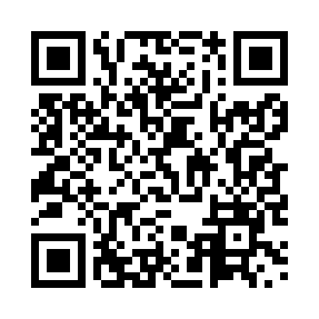
Prayer times for Busan, South Korea
Mon 1 Apr 2024 - Tue 30 Apr 2024
High Latitude Method: None
Prayer Calculation Method: Muslim World League
Asar Calculation Method: Shafi

Date | Day | Fajr | Sunrise | Dhuhr | Asr | Maghrib | Isha
1 | Mon | 4:44 | 6:11 | 12:28 | 4:01 | 6:45 | 8:06
2 | Tue | 4:43 | 6:09 | 12:27 | 4:01 | 6:46 | 8:07
3 | Wed | 4:41 | 6:08 | 12:27 | 4:02 | 6:47 | 8:08
4 | Thu | 4:40 | 6:06 | 12:27 | 4:02 | 6:48 | 8:09
5 | Fri | 4:38 | 6:05 | 12:26 | 4:02 | 6:48 | 8:10
6 | Sat | 4:36 | 6:04 | 12:26 | 4:02 | 6:49 | 8:11
7 | Sun | 4:35 | 6:02 | 12:26 | 4:02 | 6:50 | 8:12
8 | Mon | 4:33 | 6:01 | 12:26 | 4:02 | 6:51 | 8:13
9 | Tue | 4:32 | 6:00 | 12:25 | 4:03 | 6:52 | 8:14
10 | Wed | 4:30 | 5:58 | 12:25 | 4:03 | 6:52 | 8:15
11 | Thu | 4:29 | 5:57 | 12:25 | 4:03 | 6:53 | 8:16
12 | Fri | 4:27 | 5:56 | 12:24 | 4:03 | 6:54 | 8:17
13 | Sat | 4:25 | 5:54 | 12:24 | 4:03 | 6:55 | 8:18
14 | Sun | 4:24 | 5:53 | 12:24 | 4:03 | 6:56 | 8:19
15 | Mon | 4:22 | 5:52 | 12:24 | 4:03 | 6:56 | 8:20
16 | Tue | 4:21 | 5:50 | 12:24 | 4:04 | 6:57 | 8:21
17 | Wed | 4:19 | 5:49 | 12:23 | 4:04 | 6:58 | 8:22
18 | Thu | 4:18 | 5:48 | 12:23 | 4:04 | 6:59 | 8:24
19 | Fri | 4:16 | 5:47 | 12:23 | 4:04 | 7:00 | 8:25
20 | Sat | 4:15 | 5:45 | 12:23 | 4:04 | 7:00 | 8:26
21 | Sun | 4:13 | 5:44 | 12:22 | 4:04 | 7:01 | 8:27
22 | Mon | 4:12 | 5:43 | 12:22 | 4:04 | 7:02 | 8:28
23 | Tue | 4:10 | 5:42 | 12:22 | 4:04 | 7:03 | 8:29
24 | Wed | 4:09 | 5:40 | 12:22 | 4:04 | 7:04 | 8:30
25 | Thu | 4:07 | 5:39 | 12:22 | 4:04 | 7:05 | 8:31
26 | Fri | 4:06 | 5:38 | 12:22 | 4:05 | 7:05 | 8:32
27 | Sat | 4:04 | 5:37 | 12:21 | 4:05 | 7:06 | 8:33
28 | Sun | 4:03 | 5:36 | 12:21 | 4:05 | 7:07 | 8:35
29 | Mon | 4:01 | 5:35 | 12:21 | 4:05 | 7:08 | 8:36
30 | Tue | 4:00 | 5:34 | 12:21 | 4:05 | 7:09 | 8:37
Prayer times provided by https://www.salahtimes.com

