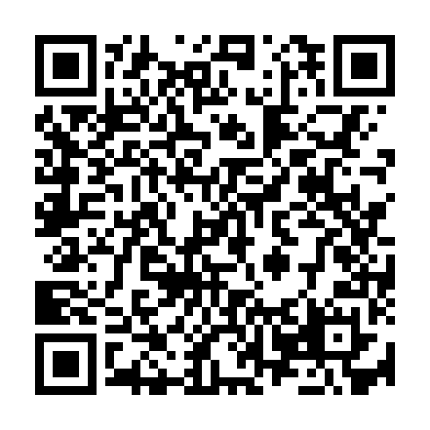
Prayer times for Kaussishkashk Kauitshinanut, Quebec, Canada
Mon 1 Jul 2024 - Wed 31 Jul 2024
High Latitude Method: Angle Based Rule
Prayer Calculation Method: Islamic Society of North America
Asar Calculation Method: Hanafi

Date | Day | Fajr | Sunrise | Dhuhr | Asr | Maghrib | Isha
1 | Mon | 2:36 | 4:27 | 12:44 | 6:20 | 9:01 | 10:52
2 | Tue | 2:36 | 4:28 | 12:44 | 6:20 | 9:00 | 10:52
3 | Wed | 2:37 | 4:29 | 12:44 | 6:20 | 9:00 | 10:52
4 | Thu | 2:37 | 4:30 | 12:45 | 6:20 | 8:59 | 10:52
5 | Fri | 2:38 | 4:30 | 12:45 | 6:20 | 8:59 | 10:52
6 | Sat | 2:38 | 4:31 | 12:45 | 6:19 | 8:58 | 10:51
7 | Sun | 2:39 | 4:32 | 12:45 | 6:19 | 8:58 | 10:51
8 | Mon | 2:39 | 4:33 | 12:45 | 6:19 | 8:57 | 10:51
9 | Tue | 2:40 | 4:34 | 12:45 | 6:19 | 8:56 | 10:51
10 | Wed | 2:40 | 4:35 | 12:46 | 6:18 | 8:55 | 10:50
11 | Thu | 2:41 | 4:36 | 12:46 | 6:18 | 8:54 | 10:50
12 | Fri | 2:41 | 4:37 | 12:46 | 6:17 | 8:54 | 10:50
13 | Sat | 2:42 | 4:39 | 12:46 | 6:17 | 8:53 | 10:49
14 | Sun | 2:43 | 4:40 | 12:46 | 6:17 | 8:52 | 10:49
15 | Mon | 2:43 | 4:41 | 12:46 | 6:16 | 8:51 | 10:48
16 | Tue | 2:44 | 4:42 | 12:46 | 6:15 | 8:50 | 10:48
17 | Wed | 2:45 | 4:43 | 12:46 | 6:15 | 8:49 | 10:47
18 | Thu | 2:45 | 4:45 | 12:46 | 6:14 | 8:47 | 10:47
19 | Fri | 2:46 | 4:46 | 12:46 | 6:14 | 8:46 | 10:46
20 | Sat | 2:47 | 4:47 | 12:46 | 6:13 | 8:45 | 10:46
21 | Sun | 2:47 | 4:49 | 12:47 | 6:12 | 8:44 | 10:45
22 | Mon | 2:48 | 4:50 | 12:47 | 6:12 | 8:42 | 10:44
23 | Tue | 2:49 | 4:51 | 12:47 | 6:11 | 8:41 | 10:44
24 | Wed | 2:49 | 4:53 | 12:47 | 6:10 | 8:40 | 10:43
25 | Thu | 2:50 | 4:54 | 12:47 | 6:09 | 8:38 | 10:42
26 | Fri | 2:51 | 4:56 | 12:47 | 6:08 | 8:37 | 10:42
27 | Sat | 2:52 | 4:57 | 12:47 | 6:08 | 8:35 | 10:41
28 | Sun | 2:52 | 4:59 | 12:47 | 6:07 | 8:34 | 10:40
29 | Mon | 2:53 | 5:00 | 12:46 | 6:06 | 8:32 | 10:39
30 | Tue | 2:54 | 5:01 | 12:46 | 6:05 | 8:31 | 10:38
31 | Wed | 2:54 | 5:03 | 12:46 | 6:04 | 8:29 | 10:38
Prayer times provided by https://www.salahtimes.com

