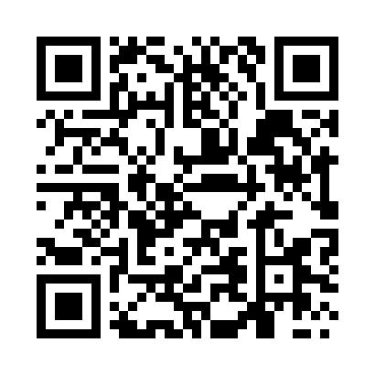
Prayer times for Djibouti, Djibouti
Mon 1 Apr 2024 - Tue 30 Apr 2024
High Latitude Method: None
Prayer Calculation Method: Muslim World League
Asar Calculation Method: Shafi

Date | Day | Fajr | Sunrise | Dhuhr | Asr | Maghrib | Isha
1 | Mon | 4:53 | 6:04 | 12:11 | 3:24 | 6:19 | 7:25
2 | Tue | 4:53 | 6:03 | 12:11 | 3:24 | 6:19 | 7:25
3 | Wed | 4:52 | 6:03 | 12:11 | 3:23 | 6:19 | 7:25
4 | Thu | 4:51 | 6:02 | 12:10 | 3:22 | 6:19 | 7:25
5 | Fri | 4:51 | 6:02 | 12:10 | 3:21 | 6:19 | 7:25
6 | Sat | 4:50 | 6:01 | 12:10 | 3:21 | 6:19 | 7:26
7 | Sun | 4:49 | 6:00 | 12:09 | 3:20 | 6:19 | 7:26
8 | Mon | 4:49 | 6:00 | 12:09 | 3:19 | 6:19 | 7:26
9 | Tue | 4:48 | 5:59 | 12:09 | 3:19 | 6:19 | 7:26
10 | Wed | 4:47 | 5:59 | 12:09 | 3:18 | 6:19 | 7:26
11 | Thu | 4:47 | 5:58 | 12:08 | 3:17 | 6:19 | 7:26
12 | Fri | 4:46 | 5:57 | 12:08 | 3:16 | 6:19 | 7:26
13 | Sat | 4:45 | 5:57 | 12:08 | 3:15 | 6:19 | 7:26
14 | Sun | 4:45 | 5:56 | 12:08 | 3:15 | 6:19 | 7:27
15 | Mon | 4:44 | 5:56 | 12:07 | 3:14 | 6:19 | 7:27
16 | Tue | 4:43 | 5:55 | 12:07 | 3:13 | 6:19 | 7:27
17 | Wed | 4:43 | 5:55 | 12:07 | 3:12 | 6:19 | 7:27
18 | Thu | 4:42 | 5:54 | 12:07 | 3:12 | 6:19 | 7:27
19 | Fri | 4:42 | 5:54 | 12:07 | 3:11 | 6:19 | 7:27
20 | Sat | 4:41 | 5:53 | 12:06 | 3:11 | 6:20 | 7:28
21 | Sun | 4:40 | 5:53 | 12:06 | 3:11 | 6:20 | 7:28
22 | Mon | 4:40 | 5:52 | 12:06 | 3:12 | 6:20 | 7:28
23 | Tue | 4:39 | 5:52 | 12:06 | 3:12 | 6:20 | 7:28
24 | Wed | 4:38 | 5:51 | 12:06 | 3:13 | 6:20 | 7:29
25 | Thu | 4:38 | 5:51 | 12:05 | 3:14 | 6:20 | 7:29
26 | Fri | 4:37 | 5:50 | 12:05 | 3:14 | 6:20 | 7:29
27 | Sat | 4:37 | 5:50 | 12:05 | 3:15 | 6:20 | 7:29
28 | Sun | 4:36 | 5:49 | 12:05 | 3:15 | 6:20 | 7:30
29 | Mon | 4:36 | 5:49 | 12:05 | 3:16 | 6:21 | 7:30
30 | Tue | 4:35 | 5:49 | 12:05 | 3:16 | 6:21 | 7:30
Prayer times provided by https://www.salahtimes.com

