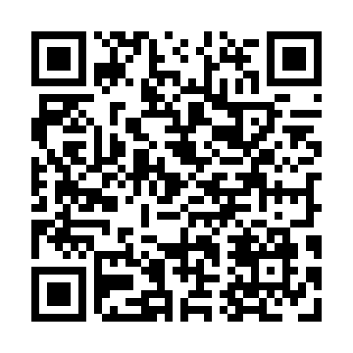
Prayer times for Victoria Cove, Newfoundland and Labrador, Canada
Mon 1 Apr 2024 - Tue 30 Apr 2024
High Latitude Method: Angle Based Rule
Prayer Calculation Method: Islamic Society of North America
Asar Calculation Method: Hanafi

Date | Day | Fajr | Sunrise | Dhuhr | Asr | Maghrib | Isha
1 | Mon | 5:13 | 6:44 | 1:12 | 5:40 | 7:40 | 9:12
2 | Tue | 5:10 | 6:42 | 1:11 | 5:41 | 7:42 | 9:14
3 | Wed | 5:08 | 6:40 | 1:11 | 5:42 | 7:43 | 9:15
4 | Thu | 5:05 | 6:38 | 1:11 | 5:43 | 7:45 | 9:17
5 | Fri | 5:03 | 6:36 | 1:10 | 5:44 | 7:46 | 9:19
6 | Sat | 5:00 | 6:34 | 1:10 | 5:45 | 7:48 | 9:21
7 | Sun | 4:58 | 6:31 | 1:10 | 5:46 | 7:49 | 9:23
8 | Mon | 4:55 | 6:29 | 1:10 | 5:47 | 7:51 | 9:25
9 | Tue | 4:53 | 6:27 | 1:09 | 5:48 | 7:52 | 9:27
10 | Wed | 4:50 | 6:25 | 1:09 | 5:50 | 7:54 | 9:29
11 | Thu | 4:48 | 6:23 | 1:09 | 5:51 | 7:55 | 9:31
12 | Fri | 4:45 | 6:21 | 1:09 | 5:52 | 7:57 | 9:33
13 | Sat | 4:43 | 6:19 | 1:08 | 5:53 | 7:58 | 9:35
14 | Sun | 4:40 | 6:17 | 1:08 | 5:54 | 8:00 | 9:37
15 | Mon | 4:38 | 6:15 | 1:08 | 5:55 | 8:01 | 9:39
16 | Tue | 4:35 | 6:13 | 1:08 | 5:56 | 8:03 | 9:41
17 | Wed | 4:33 | 6:11 | 1:07 | 5:57 | 8:05 | 9:43
18 | Thu | 4:30 | 6:09 | 1:07 | 5:58 | 8:06 | 9:45
19 | Fri | 4:28 | 6:07 | 1:07 | 5:59 | 8:08 | 9:47
20 | Sat | 4:25 | 6:05 | 1:07 | 6:00 | 8:09 | 9:49
21 | Sun | 4:23 | 6:03 | 1:07 | 6:01 | 8:11 | 9:52
22 | Mon | 4:20 | 6:01 | 1:06 | 6:02 | 8:12 | 9:54
23 | Tue | 4:18 | 6:00 | 1:06 | 6:03 | 8:14 | 9:56
24 | Wed | 4:15 | 5:58 | 1:06 | 6:04 | 8:15 | 9:58
25 | Thu | 4:13 | 5:56 | 1:06 | 6:04 | 8:17 | 10:00
26 | Fri | 4:10 | 5:54 | 1:06 | 6:05 | 8:18 | 10:03
27 | Sat | 4:08 | 5:52 | 1:06 | 6:06 | 8:20 | 10:05
28 | Sun | 4:05 | 5:50 | 1:05 | 6:07 | 8:21 | 10:07
29 | Mon | 4:03 | 5:49 | 1:05 | 6:08 | 8:23 | 10:09
30 | Tue | 4:00 | 5:47 | 1:05 | 6:09 | 8:24 | 10:12
Prayer times provided by https://www.salahtimes.com

