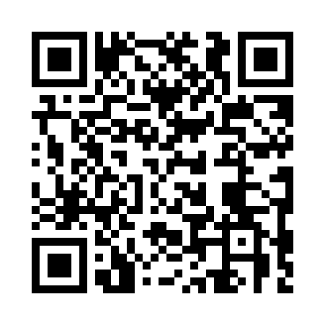
Prayer times for Bidjouka, Cameroon
Wed 1 May 2024 - Fri 31 May 2024
High Latitude Method: None
Prayer Calculation Method: Muslim World League
Asar Calculation Method: Shafi

Date | Day | Fajr | Sunrise | Dhuhr | Asr | Maghrib | Isha
1 | Wed | 4:57 | 6:08 | 12:15 | 3:35 | 6:22 | 7:29
2 | Thu | 4:57 | 6:08 | 12:15 | 3:35 | 6:22 | 7:30
3 | Fri | 4:56 | 6:08 | 12:15 | 3:35 | 6:22 | 7:30
4 | Sat | 4:56 | 6:08 | 12:15 | 3:35 | 6:22 | 7:30
5 | Sun | 4:56 | 6:08 | 12:15 | 3:36 | 6:22 | 7:30
6 | Mon | 4:55 | 6:08 | 12:15 | 3:36 | 6:22 | 7:30
7 | Tue | 4:55 | 6:07 | 12:15 | 3:36 | 6:22 | 7:30
8 | Wed | 4:55 | 6:07 | 12:15 | 3:36 | 6:22 | 7:30
9 | Thu | 4:55 | 6:07 | 12:15 | 3:36 | 6:22 | 7:30
10 | Fri | 4:54 | 6:07 | 12:15 | 3:37 | 6:22 | 7:30
11 | Sat | 4:54 | 6:07 | 12:15 | 3:37 | 6:22 | 7:31
12 | Sun | 4:54 | 6:07 | 12:14 | 3:37 | 6:22 | 7:31
13 | Mon | 4:54 | 6:07 | 12:14 | 3:37 | 6:22 | 7:31
14 | Tue | 4:54 | 6:07 | 12:14 | 3:38 | 6:22 | 7:31
15 | Wed | 4:54 | 6:07 | 12:15 | 3:38 | 6:22 | 7:31
16 | Thu | 4:53 | 6:07 | 12:15 | 3:38 | 6:22 | 7:31
17 | Fri | 4:53 | 6:07 | 12:15 | 3:38 | 6:23 | 7:32
18 | Sat | 4:53 | 6:07 | 12:15 | 3:38 | 6:23 | 7:32
19 | Sun | 4:53 | 6:07 | 12:15 | 3:39 | 6:23 | 7:32
20 | Mon | 4:53 | 6:07 | 12:15 | 3:39 | 6:23 | 7:32
21 | Tue | 4:53 | 6:07 | 12:15 | 3:39 | 6:23 | 7:33
22 | Wed | 4:53 | 6:07 | 12:15 | 3:39 | 6:23 | 7:33
23 | Thu | 4:53 | 6:07 | 12:15 | 3:40 | 6:23 | 7:33
24 | Fri | 4:53 | 6:07 | 12:15 | 3:40 | 6:23 | 7:33
25 | Sat | 4:53 | 6:07 | 12:15 | 3:40 | 6:24 | 7:33
26 | Sun | 4:53 | 6:07 | 12:15 | 3:40 | 6:24 | 7:34
27 | Mon | 4:52 | 6:07 | 12:15 | 3:41 | 6:24 | 7:34
28 | Tue | 4:52 | 6:07 | 12:15 | 3:41 | 6:24 | 7:34
29 | Wed | 4:52 | 6:07 | 12:16 | 3:41 | 6:24 | 7:34
30 | Thu | 4:52 | 6:07 | 12:16 | 3:41 | 6:24 | 7:35
31 | Fri | 4:53 | 6:07 | 12:16 | 3:42 | 6:25 | 7:35
Prayer times provided by https://www.salahtimes.com

