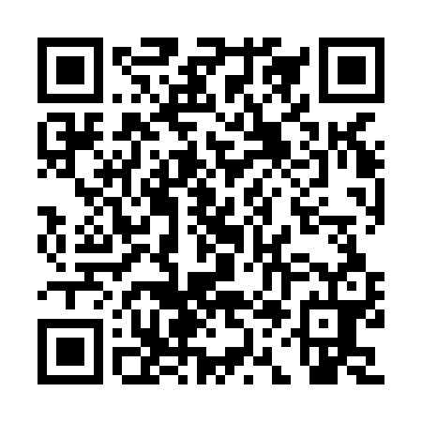
Prayer times for Kamitshetshistatshuna, Quebec, Canada
Mon 1 Jul 2024 - Wed 31 Jul 2024
High Latitude Method: Angle Based Rule
Prayer Calculation Method: Islamic Society of North America
Asar Calculation Method: Hanafi

Date | Day | Fajr | Sunrise | Dhuhr | Asr | Maghrib | Isha
1 | Mon | 2:00 | 3:37 | 12:23 | 6:10 | 9:08 | 10:45
2 | Tue | 2:01 | 3:38 | 12:23 | 6:10 | 9:08 | 10:45
3 | Wed | 2:01 | 3:39 | 12:23 | 6:10 | 9:07 | 10:45
4 | Thu | 2:02 | 3:40 | 12:24 | 6:10 | 9:06 | 10:45
5 | Fri | 2:02 | 3:41 | 12:24 | 6:09 | 9:06 | 10:44
6 | Sat | 2:03 | 3:42 | 12:24 | 6:09 | 9:05 | 10:44
7 | Sun | 2:04 | 3:44 | 12:24 | 6:09 | 9:04 | 10:44
8 | Mon | 2:04 | 3:45 | 12:24 | 6:08 | 9:03 | 10:43
9 | Tue | 2:05 | 3:46 | 12:24 | 6:08 | 9:02 | 10:43
10 | Wed | 2:06 | 3:47 | 12:24 | 6:08 | 9:01 | 10:43
11 | Thu | 2:06 | 3:49 | 12:25 | 6:07 | 9:00 | 10:42
12 | Fri | 2:07 | 3:50 | 12:25 | 6:07 | 8:59 | 10:42
13 | Sat | 2:08 | 3:52 | 12:25 | 6:06 | 8:57 | 10:41
14 | Sun | 2:09 | 3:53 | 12:25 | 6:05 | 8:56 | 10:40
15 | Mon | 2:10 | 3:54 | 12:25 | 6:05 | 8:55 | 10:40
16 | Tue | 2:10 | 3:56 | 12:25 | 6:04 | 8:53 | 10:39
17 | Wed | 2:11 | 3:58 | 12:25 | 6:03 | 8:52 | 10:38
18 | Thu | 2:12 | 3:59 | 12:25 | 6:03 | 8:51 | 10:38
19 | Fri | 2:13 | 4:01 | 12:25 | 6:02 | 8:49 | 10:37
20 | Sat | 2:14 | 4:02 | 12:25 | 6:01 | 8:48 | 10:36
21 | Sun | 2:15 | 4:04 | 12:25 | 6:00 | 8:46 | 10:35
22 | Mon | 2:15 | 4:06 | 12:25 | 5:59 | 8:44 | 10:35
23 | Tue | 2:16 | 4:07 | 12:25 | 5:58 | 8:43 | 10:34
24 | Wed | 2:17 | 4:09 | 12:25 | 5:57 | 8:41 | 10:33
25 | Thu | 2:18 | 4:11 | 12:26 | 5:56 | 8:39 | 10:32
26 | Fri | 2:19 | 4:13 | 12:25 | 5:55 | 8:37 | 10:31
27 | Sat | 2:20 | 4:15 | 12:25 | 5:54 | 8:35 | 10:30
28 | Sun | 2:21 | 4:16 | 12:25 | 5:53 | 8:34 | 10:29
29 | Mon | 2:22 | 4:18 | 12:25 | 5:52 | 8:32 | 10:28
30 | Tue | 2:22 | 4:20 | 12:25 | 5:51 | 8:30 | 10:27
31 | Wed | 2:23 | 4:22 | 12:25 | 5:50 | 8:28 | 10:26
Prayer times provided by https://www.salahtimes.com

