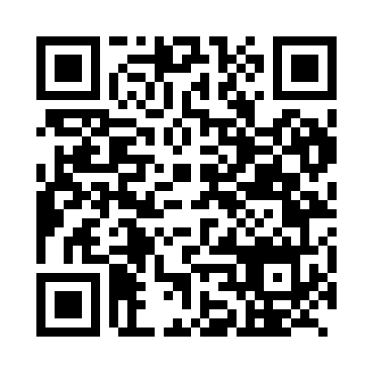
Prayer times for Zhongtang, China
Mon 1 Apr 2024 - Tue 30 Apr 2024
High Latitude Method: Angle Based Rule
Prayer Calculation Method: Muslim World League
Asar Calculation Method: Shafi

Date | Day | Fajr | Sunrise | Dhuhr | Asr | Maghrib | Isha
1 | Mon | 5:02 | 6:18 | 12:29 | 3:56 | 6:41 | 7:52
2 | Tue | 5:01 | 6:17 | 12:29 | 3:56 | 6:41 | 7:53
3 | Wed | 5:00 | 6:16 | 12:29 | 3:56 | 6:42 | 7:53
4 | Thu | 4:59 | 6:15 | 12:28 | 3:55 | 6:42 | 7:54
5 | Fri | 4:58 | 6:14 | 12:28 | 3:55 | 6:42 | 7:54
6 | Sat | 4:57 | 6:13 | 12:28 | 3:55 | 6:43 | 7:55
7 | Sun | 4:56 | 6:12 | 12:27 | 3:54 | 6:43 | 7:55
8 | Mon | 4:55 | 6:11 | 12:27 | 3:54 | 6:44 | 7:56
9 | Tue | 4:54 | 6:10 | 12:27 | 3:54 | 6:44 | 7:56
10 | Wed | 4:53 | 6:09 | 12:27 | 3:54 | 6:44 | 7:57
11 | Thu | 4:52 | 6:08 | 12:26 | 3:53 | 6:45 | 7:57
12 | Fri | 4:51 | 6:07 | 12:26 | 3:53 | 6:45 | 7:58
13 | Sat | 4:50 | 6:07 | 12:26 | 3:53 | 6:46 | 7:58
14 | Sun | 4:48 | 6:06 | 12:26 | 3:52 | 6:46 | 7:59
15 | Mon | 4:47 | 6:05 | 12:25 | 3:52 | 6:46 | 7:59
16 | Tue | 4:46 | 6:04 | 12:25 | 3:52 | 6:47 | 8:00
17 | Wed | 4:45 | 6:03 | 12:25 | 3:51 | 6:47 | 8:00
18 | Thu | 4:44 | 6:02 | 12:25 | 3:51 | 6:48 | 8:01
19 | Fri | 4:43 | 6:01 | 12:24 | 3:51 | 6:48 | 8:01
20 | Sat | 4:42 | 6:01 | 12:24 | 3:50 | 6:48 | 8:02
21 | Sun | 4:41 | 6:00 | 12:24 | 3:50 | 6:49 | 8:02
22 | Mon | 4:40 | 5:59 | 12:24 | 3:50 | 6:49 | 8:03
23 | Tue | 4:39 | 5:58 | 12:24 | 3:49 | 6:50 | 8:04
24 | Wed | 4:39 | 5:57 | 12:24 | 3:49 | 6:50 | 8:04
25 | Thu | 4:38 | 5:57 | 12:23 | 3:49 | 6:50 | 8:05
26 | Fri | 4:37 | 5:56 | 12:23 | 3:49 | 6:51 | 8:05
27 | Sat | 4:36 | 5:55 | 12:23 | 3:48 | 6:51 | 8:06
28 | Sun | 4:35 | 5:54 | 12:23 | 3:48 | 6:52 | 8:07
29 | Mon | 4:34 | 5:54 | 12:23 | 3:48 | 6:52 | 8:07
30 | Tue | 4:33 | 5:53 | 12:23 | 3:47 | 6:53 | 8:08
Prayer times provided by https://www.salahtimes.com

