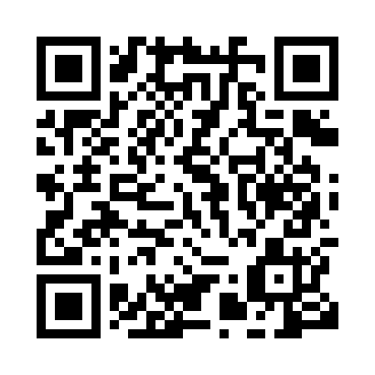
Prayer times for Bare, Cameroon
Mon 1 Apr 2024 - Tue 30 Apr 2024
High Latitude Method: None
Prayer Calculation Method: Muslim World League
Asar Calculation Method: Shafi

Date | Day | Fajr | Sunrise | Dhuhr | Asr | Maghrib | Isha
1 | Mon | 5:10 | 6:19 | 12:24 | 3:25 | 6:29 | 7:34
2 | Tue | 5:09 | 6:18 | 12:24 | 3:25 | 6:29 | 7:34
3 | Wed | 5:09 | 6:18 | 12:23 | 3:25 | 6:29 | 7:34
4 | Thu | 5:08 | 6:18 | 12:23 | 3:26 | 6:28 | 7:34
5 | Fri | 5:08 | 6:17 | 12:23 | 3:26 | 6:28 | 7:34
6 | Sat | 5:07 | 6:17 | 12:22 | 3:27 | 6:28 | 7:34
7 | Sun | 5:07 | 6:16 | 12:22 | 3:27 | 6:28 | 7:34
8 | Mon | 5:06 | 6:16 | 12:22 | 3:28 | 6:28 | 7:33
9 | Tue | 5:06 | 6:16 | 12:22 | 3:28 | 6:28 | 7:33
10 | Wed | 5:05 | 6:15 | 12:21 | 3:29 | 6:28 | 7:33
11 | Thu | 5:05 | 6:15 | 12:21 | 3:29 | 6:27 | 7:33
12 | Fri | 5:04 | 6:14 | 12:21 | 3:29 | 6:27 | 7:33
13 | Sat | 5:04 | 6:14 | 12:21 | 3:30 | 6:27 | 7:33
14 | Sun | 5:03 | 6:14 | 12:20 | 3:30 | 6:27 | 7:33
15 | Mon | 5:03 | 6:13 | 12:20 | 3:30 | 6:27 | 7:33
16 | Tue | 5:03 | 6:13 | 12:20 | 3:31 | 6:27 | 7:33
17 | Wed | 5:02 | 6:12 | 12:20 | 3:31 | 6:27 | 7:33
18 | Thu | 5:02 | 6:12 | 12:19 | 3:32 | 6:27 | 7:33
19 | Fri | 5:01 | 6:12 | 12:19 | 3:32 | 6:27 | 7:33
20 | Sat | 5:01 | 6:11 | 12:19 | 3:32 | 6:27 | 7:33
21 | Sun | 5:00 | 6:11 | 12:19 | 3:33 | 6:26 | 7:33
22 | Mon | 5:00 | 6:11 | 12:19 | 3:33 | 6:26 | 7:33
23 | Tue | 4:59 | 6:10 | 12:18 | 3:33 | 6:26 | 7:33
24 | Wed | 4:59 | 6:10 | 12:18 | 3:33 | 6:26 | 7:33
25 | Thu | 4:59 | 6:10 | 12:18 | 3:34 | 6:26 | 7:33
26 | Fri | 4:58 | 6:10 | 12:18 | 3:34 | 6:26 | 7:33
27 | Sat | 4:58 | 6:09 | 12:18 | 3:34 | 6:26 | 7:33
28 | Sun | 4:58 | 6:09 | 12:18 | 3:35 | 6:26 | 7:34
29 | Mon | 4:57 | 6:09 | 12:17 | 3:35 | 6:26 | 7:34
30 | Tue | 4:57 | 6:09 | 12:17 | 3:35 | 6:26 | 7:34
Prayer times provided by https://www.salahtimes.com

