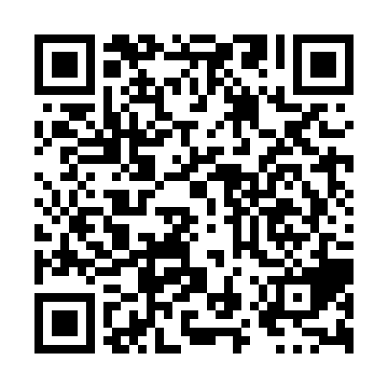
Prayer times for Kaaitukameshtesht, Quebec, Canada
Mon 1 Jul 2024 - Wed 31 Jul 2024
High Latitude Method: Angle Based Rule
Prayer Calculation Method: Islamic Society of North America
Asar Calculation Method: Hanafi

Date | Day | Fajr | Sunrise | Dhuhr | Asr | Maghrib | Isha
1 | Mon | 2:24 | 4:16 | 12:32 | 6:08 | 8:48 | 10:40
2 | Tue | 2:24 | 4:17 | 12:32 | 6:08 | 8:47 | 10:40
3 | Wed | 2:25 | 4:17 | 12:32 | 6:08 | 8:47 | 10:40
4 | Thu | 2:25 | 4:18 | 12:32 | 6:07 | 8:46 | 10:39
5 | Fri | 2:26 | 4:19 | 12:33 | 6:07 | 8:46 | 10:39
6 | Sat | 2:26 | 4:20 | 12:33 | 6:07 | 8:45 | 10:39
7 | Sun | 2:27 | 4:21 | 12:33 | 6:07 | 8:45 | 10:39
8 | Mon | 2:27 | 4:22 | 12:33 | 6:06 | 8:44 | 10:38
9 | Tue | 2:28 | 4:23 | 12:33 | 6:06 | 8:43 | 10:38
10 | Wed | 2:29 | 4:24 | 12:33 | 6:06 | 8:42 | 10:38
11 | Thu | 2:29 | 4:25 | 12:34 | 6:05 | 8:42 | 10:37
12 | Fri | 2:30 | 4:26 | 12:34 | 6:05 | 8:41 | 10:37
13 | Sat | 2:30 | 4:27 | 12:34 | 6:05 | 8:40 | 10:37
14 | Sun | 2:31 | 4:28 | 12:34 | 6:04 | 8:39 | 10:36
15 | Mon | 2:32 | 4:30 | 12:34 | 6:04 | 8:38 | 10:36
16 | Tue | 2:32 | 4:31 | 12:34 | 6:03 | 8:37 | 10:35
17 | Wed | 2:33 | 4:32 | 12:34 | 6:03 | 8:36 | 10:35
18 | Thu | 2:34 | 4:33 | 12:34 | 6:02 | 8:35 | 10:34
19 | Fri | 2:34 | 4:35 | 12:34 | 6:01 | 8:33 | 10:34
20 | Sat | 2:35 | 4:36 | 12:34 | 6:01 | 8:32 | 10:33
21 | Sun | 2:36 | 4:37 | 12:34 | 6:00 | 8:31 | 10:33
22 | Mon | 2:36 | 4:39 | 12:34 | 5:59 | 8:30 | 10:32
23 | Tue | 2:37 | 4:40 | 12:34 | 5:58 | 8:28 | 10:31
24 | Wed | 2:38 | 4:41 | 12:34 | 5:58 | 8:27 | 10:31
25 | Thu | 2:38 | 4:43 | 12:34 | 5:57 | 8:26 | 10:30
26 | Fri | 2:39 | 4:44 | 12:34 | 5:56 | 8:24 | 10:29
27 | Sat | 2:40 | 4:46 | 12:34 | 5:55 | 8:23 | 10:28
28 | Sun | 2:41 | 4:47 | 12:34 | 5:54 | 8:21 | 10:28
29 | Mon | 2:41 | 4:48 | 12:34 | 5:53 | 8:20 | 10:27
30 | Tue | 2:42 | 4:50 | 12:34 | 5:52 | 8:18 | 10:26
31 | Wed | 2:43 | 4:51 | 12:34 | 5:51 | 8:16 | 10:24
Prayer times provided by https://www.salahtimes.com

