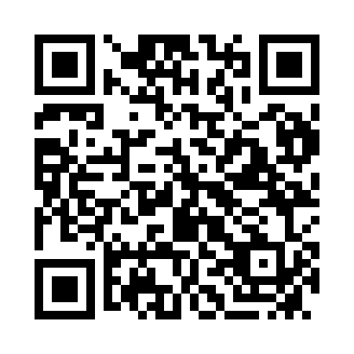
Prayer times for Bulimba, Australia
Wed 1 May 2024 - Fri 31 May 2024
High Latitude Method: None
Prayer Calculation Method: Muslim World League
Asar Calculation Method: Shafi

Date | Day | Fajr | Sunrise | Dhuhr | Asr | Maghrib | Isha
1 | Wed | 4:54 | 6:13 | 11:45 | 2:53 | 5:16 | 6:31
2 | Thu | 4:54 | 6:14 | 11:45 | 2:53 | 5:15 | 6:30
3 | Fri | 4:55 | 6:14 | 11:45 | 2:52 | 5:15 | 6:30
4 | Sat | 4:55 | 6:15 | 11:45 | 2:52 | 5:14 | 6:29
5 | Sun | 4:56 | 6:15 | 11:45 | 2:51 | 5:13 | 6:28
6 | Mon | 4:56 | 6:16 | 11:44 | 2:51 | 5:12 | 6:28
7 | Tue | 4:57 | 6:17 | 11:44 | 2:50 | 5:12 | 6:27
8 | Wed | 4:57 | 6:17 | 11:44 | 2:49 | 5:11 | 6:27
9 | Thu | 4:58 | 6:18 | 11:44 | 2:49 | 5:10 | 6:26
10 | Fri | 4:58 | 6:18 | 11:44 | 2:48 | 5:10 | 6:26
11 | Sat | 4:58 | 6:19 | 11:44 | 2:48 | 5:09 | 6:25
12 | Sun | 4:59 | 6:19 | 11:44 | 2:48 | 5:09 | 6:25
13 | Mon | 4:59 | 6:20 | 11:44 | 2:47 | 5:08 | 6:24
14 | Tue | 5:00 | 6:21 | 11:44 | 2:47 | 5:08 | 6:24
15 | Wed | 5:00 | 6:21 | 11:44 | 2:46 | 5:07 | 6:23
16 | Thu | 5:01 | 6:22 | 11:44 | 2:46 | 5:06 | 6:23
17 | Fri | 5:01 | 6:22 | 11:44 | 2:45 | 5:06 | 6:22
18 | Sat | 5:02 | 6:23 | 11:44 | 2:45 | 5:05 | 6:22
19 | Sun | 5:02 | 6:23 | 11:44 | 2:45 | 5:05 | 6:22
20 | Mon | 5:02 | 6:24 | 11:44 | 2:44 | 5:05 | 6:21
21 | Tue | 5:03 | 6:24 | 11:44 | 2:44 | 5:04 | 6:21
22 | Wed | 5:03 | 6:25 | 11:44 | 2:44 | 5:04 | 6:21
23 | Thu | 5:04 | 6:26 | 11:45 | 2:43 | 5:03 | 6:20
24 | Fri | 5:04 | 6:26 | 11:45 | 2:43 | 5:03 | 6:20
25 | Sat | 5:05 | 6:27 | 11:45 | 2:43 | 5:03 | 6:20
26 | Sun | 5:05 | 6:27 | 11:45 | 2:43 | 5:02 | 6:20
27 | Mon | 5:06 | 6:28 | 11:45 | 2:42 | 5:02 | 6:20
28 | Tue | 5:06 | 6:28 | 11:45 | 2:42 | 5:02 | 6:19
29 | Wed | 5:06 | 6:29 | 11:45 | 2:42 | 5:02 | 6:19
30 | Thu | 5:07 | 6:29 | 11:45 | 2:42 | 5:01 | 6:19
31 | Fri | 5:07 | 6:30 | 11:46 | 2:42 | 5:01 | 6:19
Prayer times provided by https://www.salahtimes.com

