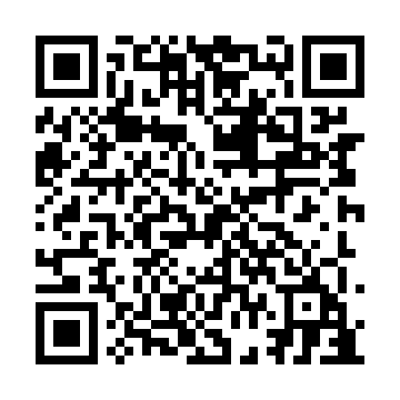
Prayer times for Cloridorme-Ouest, Quebec, Canada
Mon 1 Jul 2024 - Wed 31 Jul 2024
High Latitude Method: Angle Based Rule
Prayer Calculation Method: Islamic Society of North America
Asar Calculation Method: Hanafi

Date | Day | Fajr | Sunrise | Dhuhr | Asr | Maghrib | Isha
1 | Mon | 2:21 | 4:19 | 12:23 | 5:54 | 8:28 | 10:26
2 | Tue | 2:22 | 4:20 | 12:24 | 5:54 | 8:27 | 10:25
3 | Wed | 2:22 | 4:20 | 12:24 | 5:54 | 8:27 | 10:25
4 | Thu | 2:22 | 4:21 | 12:24 | 5:54 | 8:27 | 10:25
5 | Fri | 2:23 | 4:22 | 12:24 | 5:54 | 8:26 | 10:25
6 | Sat | 2:23 | 4:23 | 12:24 | 5:54 | 8:26 | 10:25
7 | Sun | 2:24 | 4:23 | 12:24 | 5:53 | 8:25 | 10:25
8 | Mon | 2:24 | 4:24 | 12:25 | 5:53 | 8:25 | 10:24
9 | Tue | 2:25 | 4:25 | 12:25 | 5:53 | 8:24 | 10:24
10 | Wed | 2:25 | 4:26 | 12:25 | 5:53 | 8:23 | 10:24
11 | Thu | 2:26 | 4:27 | 12:25 | 5:52 | 8:22 | 10:24
12 | Fri | 2:27 | 4:28 | 12:25 | 5:52 | 8:22 | 10:23
13 | Sat | 2:27 | 4:29 | 12:25 | 5:51 | 8:21 | 10:23
14 | Sun | 2:28 | 4:30 | 12:25 | 5:51 | 8:20 | 10:23
15 | Mon | 2:28 | 4:31 | 12:25 | 5:51 | 8:19 | 10:22
16 | Tue | 2:29 | 4:32 | 12:26 | 5:50 | 8:18 | 10:22
17 | Wed | 2:29 | 4:34 | 12:26 | 5:50 | 8:17 | 10:21
18 | Thu | 2:30 | 4:35 | 12:26 | 5:49 | 8:16 | 10:21
19 | Fri | 2:31 | 4:36 | 12:26 | 5:49 | 8:15 | 10:20
20 | Sat | 2:31 | 4:37 | 12:26 | 5:48 | 8:14 | 10:20
21 | Sun | 2:32 | 4:38 | 12:26 | 5:47 | 8:13 | 10:18
22 | Mon | 2:35 | 4:39 | 12:26 | 5:47 | 8:12 | 10:16
23 | Tue | 2:37 | 4:41 | 12:26 | 5:46 | 8:11 | 10:14
24 | Wed | 2:39 | 4:42 | 12:26 | 5:45 | 8:09 | 10:11
25 | Thu | 2:42 | 4:43 | 12:26 | 5:45 | 8:08 | 10:09
26 | Fri | 2:44 | 4:45 | 12:26 | 5:44 | 8:07 | 10:07
27 | Sat | 2:46 | 4:46 | 12:26 | 5:43 | 8:05 | 10:05
28 | Sun | 2:48 | 4:47 | 12:26 | 5:42 | 8:04 | 10:02
29 | Mon | 2:51 | 4:48 | 12:26 | 5:41 | 8:03 | 10:00
30 | Tue | 2:53 | 4:50 | 12:26 | 5:40 | 8:01 | 9:57
31 | Wed | 2:55 | 4:51 | 12:26 | 5:40 | 8:00 | 9:55
Prayer times provided by https://www.salahtimes.com

