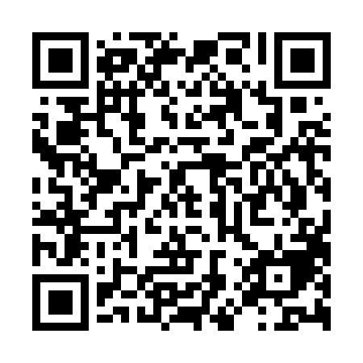
Prayer times for Trevesenhammer, Germany
Wed 1 May 2024 - Fri 31 May 2024
High Latitude Method: Angle Based Rule
Prayer Calculation Method: Muslim World League
Asar Calculation Method: Shafi

Date | Day | Fajr | Sunrise | Dhuhr | Asr | Maghrib | Isha
1 | Wed | 3:29 | 5:48 | 1:09 | 5:11 | 8:31 | 10:41
2 | Thu | 3:26 | 5:46 | 1:09 | 5:11 | 8:33 | 10:43
3 | Fri | 3:23 | 5:45 | 1:09 | 5:12 | 8:34 | 10:46
4 | Sat | 3:20 | 5:43 | 1:09 | 5:12 | 8:36 | 10:49
5 | Sun | 3:16 | 5:41 | 1:09 | 5:13 | 8:37 | 10:51
6 | Mon | 3:13 | 5:40 | 1:09 | 5:13 | 8:39 | 10:54
7 | Tue | 3:10 | 5:38 | 1:09 | 5:14 | 8:40 | 10:57
8 | Wed | 3:07 | 5:36 | 1:09 | 5:15 | 8:42 | 11:00
9 | Thu | 3:04 | 5:35 | 1:09 | 5:15 | 8:43 | 11:03
10 | Fri | 3:00 | 5:33 | 1:08 | 5:16 | 8:44 | 11:06
11 | Sat | 2:57 | 5:32 | 1:08 | 5:16 | 8:46 | 11:09
12 | Sun | 2:54 | 5:30 | 1:08 | 5:17 | 8:47 | 11:11
13 | Mon | 2:53 | 5:29 | 1:08 | 5:17 | 8:49 | 11:14
14 | Tue | 2:52 | 5:27 | 1:08 | 5:18 | 8:50 | 11:17
15 | Wed | 2:52 | 5:26 | 1:08 | 5:19 | 8:52 | 11:17
16 | Thu | 2:51 | 5:25 | 1:08 | 5:19 | 8:53 | 11:18
17 | Fri | 2:51 | 5:23 | 1:09 | 5:20 | 8:54 | 11:19
18 | Sat | 2:50 | 5:22 | 1:09 | 5:20 | 8:56 | 11:19
19 | Sun | 2:50 | 5:21 | 1:09 | 5:21 | 8:57 | 11:20
20 | Mon | 2:49 | 5:20 | 1:09 | 5:21 | 8:58 | 11:20
21 | Tue | 2:49 | 5:18 | 1:09 | 5:22 | 9:00 | 11:21
22 | Wed | 2:48 | 5:17 | 1:09 | 5:22 | 9:01 | 11:22
23 | Thu | 2:48 | 5:16 | 1:09 | 5:23 | 9:02 | 11:22
24 | Fri | 2:48 | 5:15 | 1:09 | 5:23 | 9:03 | 11:23
25 | Sat | 2:47 | 5:14 | 1:09 | 5:24 | 9:05 | 11:23
26 | Sun | 2:47 | 5:13 | 1:09 | 5:24 | 9:06 | 11:24
27 | Mon | 2:47 | 5:12 | 1:09 | 5:25 | 9:07 | 11:24
28 | Tue | 2:46 | 5:11 | 1:09 | 5:25 | 9:08 | 11:25
29 | Wed | 2:46 | 5:10 | 1:10 | 5:25 | 9:09 | 11:26
30 | Thu | 2:46 | 5:10 | 1:10 | 5:26 | 9:10 | 11:26
31 | Fri | 2:46 | 5:09 | 1:10 | 5:26 | 9:11 | 11:27
Prayer times provided by https://www.salahtimes.com

