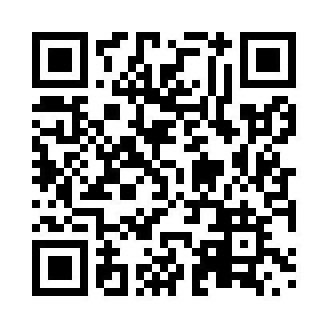
Prayer times for Tour-Rita, Quebec, Canada
Wed 1 May 2024 - Fri 31 May 2024
High Latitude Method: Angle Based Rule
Prayer Calculation Method: Islamic Society of North America
Asar Calculation Method: Hanafi

Date | Day | Fajr | Sunrise | Dhuhr | Asr | Maghrib | Isha
1 | Wed | 3:07 | 5:00 | 12:23 | 5:30 | 7:48 | 9:41
2 | Thu | 3:05 | 4:58 | 12:23 | 5:31 | 7:49 | 9:43
3 | Fri | 3:02 | 4:56 | 12:23 | 5:32 | 7:51 | 9:46
4 | Sat | 2:59 | 4:55 | 12:23 | 5:33 | 7:52 | 9:48
5 | Sun | 2:56 | 4:53 | 12:23 | 5:33 | 7:54 | 9:51
6 | Mon | 2:54 | 4:51 | 12:23 | 5:34 | 7:55 | 9:53
7 | Tue | 2:51 | 4:49 | 12:23 | 5:35 | 7:57 | 9:56
8 | Wed | 2:48 | 4:48 | 12:23 | 5:36 | 7:58 | 9:59
9 | Thu | 2:46 | 4:46 | 12:23 | 5:37 | 8:00 | 10:01
10 | Fri | 2:43 | 4:45 | 12:23 | 5:38 | 8:01 | 10:04
11 | Sat | 2:40 | 4:43 | 12:23 | 5:39 | 8:03 | 10:06
12 | Sun | 2:38 | 4:42 | 12:23 | 5:40 | 8:04 | 10:09
13 | Mon | 2:35 | 4:40 | 12:23 | 5:41 | 8:06 | 10:12
14 | Tue | 2:32 | 4:39 | 12:23 | 5:42 | 8:07 | 10:14
15 | Wed | 2:30 | 4:37 | 12:23 | 5:42 | 8:09 | 10:16
16 | Thu | 2:29 | 4:36 | 12:23 | 5:43 | 8:10 | 10:17
17 | Fri | 2:29 | 4:35 | 12:23 | 5:44 | 8:12 | 10:17
18 | Sat | 2:28 | 4:33 | 12:23 | 5:45 | 8:13 | 10:18
19 | Sun | 2:28 | 4:32 | 12:23 | 5:46 | 8:14 | 10:19
20 | Mon | 2:27 | 4:31 | 12:23 | 5:47 | 8:16 | 10:19
21 | Tue | 2:26 | 4:29 | 12:23 | 5:47 | 8:17 | 10:20
22 | Wed | 2:26 | 4:28 | 12:23 | 5:48 | 8:18 | 10:21
23 | Thu | 2:25 | 4:27 | 12:23 | 5:49 | 8:20 | 10:21
24 | Fri | 2:25 | 4:26 | 12:23 | 5:50 | 8:21 | 10:22
25 | Sat | 2:24 | 4:25 | 12:23 | 5:50 | 8:22 | 10:23
26 | Sun | 2:24 | 4:24 | 12:23 | 5:51 | 8:23 | 10:23
27 | Mon | 2:23 | 4:23 | 12:24 | 5:52 | 8:24 | 10:24
28 | Tue | 2:23 | 4:22 | 12:24 | 5:52 | 8:26 | 10:25
29 | Wed | 2:23 | 4:21 | 12:24 | 5:53 | 8:27 | 10:25
30 | Thu | 2:22 | 4:20 | 12:24 | 5:54 | 8:28 | 10:26
31 | Fri | 2:22 | 4:20 | 12:24 | 5:54 | 8:29 | 10:27
Prayer times provided by https://www.salahtimes.com

