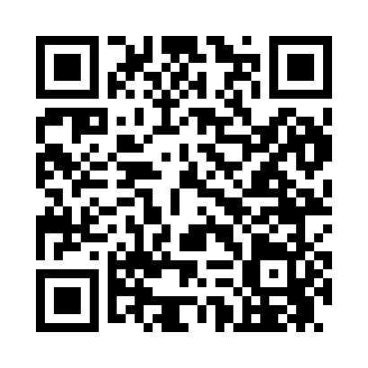
Prayer times for Copalis Beach, Washington, USA
Mon 1 Apr 2024 - Tue 30 Apr 2024
High Latitude Method: Angle Based Rule
Prayer Calculation Method: Islamic Society of North America
Asar Calculation Method: Shafi

Date | Day | Fajr | Sunrise | Dhuhr | Asr | Maghrib | Isha
1 | Mon | 5:27 | 6:54 | 1:20 | 4:55 | 7:47 | 9:14
2 | Tue | 5:25 | 6:52 | 1:20 | 4:56 | 7:48 | 9:16
3 | Wed | 5:23 | 6:50 | 1:20 | 4:57 | 7:50 | 9:18
4 | Thu | 5:21 | 6:48 | 1:19 | 4:57 | 7:51 | 9:19
5 | Fri | 5:18 | 6:46 | 1:19 | 4:58 | 7:53 | 9:21
6 | Sat | 5:16 | 6:45 | 1:19 | 4:58 | 7:54 | 9:23
7 | Sun | 5:14 | 6:43 | 1:19 | 4:59 | 7:55 | 9:24
8 | Mon | 5:12 | 6:41 | 1:18 | 5:00 | 7:57 | 9:26
9 | Tue | 5:09 | 6:39 | 1:18 | 5:00 | 7:58 | 9:28
10 | Wed | 5:07 | 6:37 | 1:18 | 5:01 | 8:00 | 9:30
11 | Thu | 5:05 | 6:35 | 1:18 | 5:02 | 8:01 | 9:31
12 | Fri | 5:02 | 6:33 | 1:17 | 5:02 | 8:02 | 9:33
13 | Sat | 5:00 | 6:31 | 1:17 | 5:03 | 8:04 | 9:35
14 | Sun | 4:58 | 6:29 | 1:17 | 5:03 | 8:05 | 9:37
15 | Mon | 4:56 | 6:27 | 1:17 | 5:04 | 8:06 | 9:39
16 | Tue | 4:53 | 6:26 | 1:16 | 5:05 | 8:08 | 9:40
17 | Wed | 4:51 | 6:24 | 1:16 | 5:05 | 8:09 | 9:42
18 | Thu | 4:49 | 6:22 | 1:16 | 5:06 | 8:11 | 9:44
19 | Fri | 4:46 | 6:20 | 1:16 | 5:06 | 8:12 | 9:46
20 | Sat | 4:44 | 6:18 | 1:15 | 5:07 | 8:13 | 9:48
21 | Sun | 4:42 | 6:16 | 1:15 | 5:07 | 8:15 | 9:50
22 | Mon | 4:40 | 6:15 | 1:15 | 5:08 | 8:16 | 9:52
23 | Tue | 4:37 | 6:13 | 1:15 | 5:08 | 8:18 | 9:54
24 | Wed | 4:35 | 6:11 | 1:15 | 5:09 | 8:19 | 9:55
25 | Thu | 4:33 | 6:10 | 1:15 | 5:09 | 8:20 | 9:57
26 | Fri | 4:31 | 6:08 | 1:14 | 5:10 | 8:22 | 9:59
27 | Sat | 4:28 | 6:06 | 1:14 | 5:10 | 8:23 | 10:01
28 | Sun | 4:26 | 6:05 | 1:14 | 5:11 | 8:24 | 10:03
29 | Mon | 4:24 | 6:03 | 1:14 | 5:11 | 8:26 | 10:05
30 | Tue | 4:22 | 6:01 | 1:14 | 5:12 | 8:27 | 10:07
Prayer times provided by https://www.salahtimes.com

