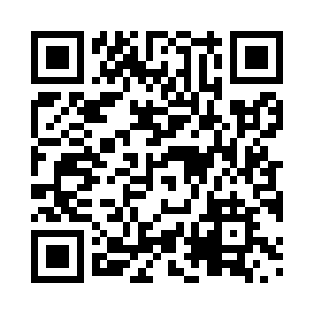
Prayer times for Stormont, Nova Scotia, Canada
Mon 1 Jul 2024 - Wed 31 Jul 2024
High Latitude Method: Angle Based Rule
Prayer Calculation Method: Islamic Society of North America
Asar Calculation Method: Hanafi

Date | Day | Fajr | Sunrise | Dhuhr | Asr | Maghrib | Isha
1 | Mon | 3:27 | 5:24 | 1:11 | 6:33 | 8:58 | 10:54
2 | Tue | 3:28 | 5:24 | 1:11 | 6:33 | 8:58 | 10:54
3 | Wed | 3:29 | 5:25 | 1:11 | 6:33 | 8:58 | 10:53
4 | Thu | 3:30 | 5:25 | 1:12 | 6:33 | 8:57 | 10:52
5 | Fri | 3:31 | 5:26 | 1:12 | 6:33 | 8:57 | 10:52
6 | Sat | 3:32 | 5:27 | 1:12 | 6:33 | 8:57 | 10:51
7 | Sun | 3:33 | 5:28 | 1:12 | 6:33 | 8:56 | 10:50
8 | Mon | 3:35 | 5:28 | 1:12 | 6:33 | 8:56 | 10:49
9 | Tue | 3:36 | 5:29 | 1:12 | 6:32 | 8:55 | 10:48
10 | Wed | 3:37 | 5:30 | 1:12 | 6:32 | 8:55 | 10:47
11 | Thu | 3:39 | 5:31 | 1:13 | 6:32 | 8:54 | 10:46
12 | Fri | 3:40 | 5:32 | 1:13 | 6:32 | 8:53 | 10:45
13 | Sat | 3:41 | 5:33 | 1:13 | 6:31 | 8:53 | 10:44
14 | Sun | 3:43 | 5:33 | 1:13 | 6:31 | 8:52 | 10:42
15 | Mon | 3:44 | 5:34 | 1:13 | 6:31 | 8:51 | 10:41
16 | Tue | 3:46 | 5:35 | 1:13 | 6:30 | 8:51 | 10:40
17 | Wed | 3:47 | 5:36 | 1:13 | 6:30 | 8:50 | 10:38
18 | Thu | 3:49 | 5:37 | 1:13 | 6:30 | 8:49 | 10:37
19 | Fri | 3:50 | 5:38 | 1:13 | 6:29 | 8:48 | 10:35
20 | Sat | 3:52 | 5:39 | 1:13 | 6:29 | 8:47 | 10:34
21 | Sun | 3:54 | 5:40 | 1:13 | 6:28 | 8:46 | 10:32
22 | Mon | 3:55 | 5:41 | 1:13 | 6:28 | 8:45 | 10:31
23 | Tue | 3:57 | 5:42 | 1:13 | 6:27 | 8:44 | 10:29
24 | Wed | 3:59 | 5:43 | 1:14 | 6:26 | 8:43 | 10:28
25 | Thu | 4:00 | 5:45 | 1:14 | 6:26 | 8:42 | 10:26
26 | Fri | 4:02 | 5:46 | 1:14 | 6:25 | 8:41 | 10:24
27 | Sat | 4:04 | 5:47 | 1:13 | 6:24 | 8:40 | 10:22
28 | Sun | 4:05 | 5:48 | 1:13 | 6:24 | 8:39 | 10:21
29 | Mon | 4:07 | 5:49 | 1:13 | 6:23 | 8:37 | 10:19
30 | Tue | 4:09 | 5:50 | 1:13 | 6:22 | 8:36 | 10:17
31 | Wed | 4:10 | 5:51 | 1:13 | 6:22 | 8:35 | 10:15
Prayer times provided by https://www.salahtimes.com

