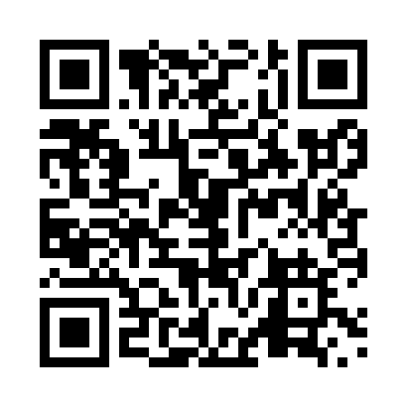
Prayer times for Baker, British Columbia, Canada
Wed 1 May 2024 - Fri 31 May 2024
High Latitude Method: Angle Based Rule
Prayer Calculation Method: Islamic Society of North America
Asar Calculation Method: Hanafi

Date | Day | Fajr | Sunrise | Dhuhr | Asr | Maghrib | Isha
1 | Wed | 4:30 | 6:19 | 1:39 | 6:45 | 9:01 | 10:50
2 | Thu | 4:28 | 6:17 | 1:39 | 6:46 | 9:02 | 10:52
3 | Fri | 4:25 | 6:15 | 1:39 | 6:47 | 9:04 | 10:54
4 | Sat | 4:23 | 6:14 | 1:39 | 6:47 | 9:05 | 10:57
5 | Sun | 4:20 | 6:12 | 1:39 | 6:48 | 9:07 | 10:59
6 | Mon | 4:18 | 6:11 | 1:39 | 6:49 | 9:08 | 11:01
7 | Tue | 4:15 | 6:09 | 1:39 | 6:50 | 9:10 | 11:04
8 | Wed | 4:13 | 6:07 | 1:39 | 6:51 | 9:11 | 11:06
9 | Thu | 4:10 | 6:06 | 1:39 | 6:52 | 9:12 | 11:08
10 | Fri | 4:08 | 6:04 | 1:39 | 6:53 | 9:14 | 11:11
11 | Sat | 4:06 | 6:03 | 1:39 | 6:54 | 9:15 | 11:13
12 | Sun | 4:03 | 6:01 | 1:39 | 6:54 | 9:17 | 11:16
13 | Mon | 4:01 | 6:00 | 1:39 | 6:55 | 9:18 | 11:18
14 | Tue | 3:58 | 5:59 | 1:39 | 6:56 | 9:19 | 11:20
15 | Wed | 3:56 | 5:57 | 1:39 | 6:57 | 9:21 | 11:23
16 | Thu | 3:54 | 5:56 | 1:39 | 6:58 | 9:22 | 11:25
17 | Fri | 3:51 | 5:55 | 1:39 | 6:58 | 9:24 | 11:28
18 | Sat | 3:49 | 5:53 | 1:39 | 6:59 | 9:25 | 11:30
19 | Sun | 3:47 | 5:52 | 1:39 | 7:00 | 9:26 | 11:32
20 | Mon | 3:45 | 5:51 | 1:39 | 7:01 | 9:27 | 11:33
21 | Tue | 3:45 | 5:50 | 1:39 | 7:02 | 9:29 | 11:34
22 | Wed | 3:44 | 5:49 | 1:39 | 7:02 | 9:30 | 11:35
23 | Thu | 3:44 | 5:48 | 1:39 | 7:03 | 9:31 | 11:35
24 | Fri | 3:43 | 5:47 | 1:39 | 7:04 | 9:32 | 11:36
25 | Sat | 3:43 | 5:46 | 1:39 | 7:04 | 9:34 | 11:37
26 | Sun | 3:42 | 5:45 | 1:39 | 7:05 | 9:35 | 11:37
27 | Mon | 3:42 | 5:44 | 1:40 | 7:06 | 9:36 | 11:38
28 | Tue | 3:41 | 5:43 | 1:40 | 7:06 | 9:37 | 11:38
29 | Wed | 3:41 | 5:42 | 1:40 | 7:07 | 9:38 | 11:39
30 | Thu | 3:41 | 5:41 | 1:40 | 7:08 | 9:39 | 11:40
31 | Fri | 3:41 | 5:41 | 1:40 | 7:08 | 9:40 | 11:40
Prayer times provided by https://www.salahtimes.com

