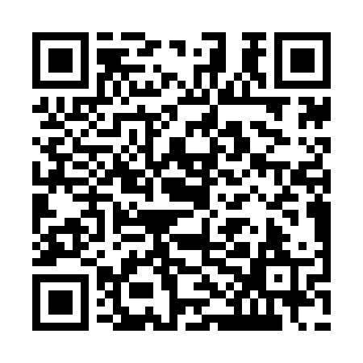
Prayer times for Point Fortin, Trinidad And Tobago
Wed 1 May 2024 - Fri 31 May 2024
High Latitude Method: None
Prayer Calculation Method: Muslim World League
Asar Calculation Method: Shafi

Date | Day | Fajr | Sunrise | Dhuhr | Asr | Maghrib | Isha
1 | Wed | 4:36 | 5:49 | 12:04 | 3:18 | 6:19 | 7:28
2 | Thu | 4:35 | 5:49 | 12:04 | 3:18 | 6:19 | 7:28
3 | Fri | 4:35 | 5:48 | 12:03 | 3:19 | 6:19 | 7:28
4 | Sat | 4:34 | 5:48 | 12:03 | 3:19 | 6:19 | 7:28
5 | Sun | 4:34 | 5:48 | 12:03 | 3:19 | 6:19 | 7:29
6 | Mon | 4:34 | 5:47 | 12:03 | 3:20 | 6:19 | 7:29
7 | Tue | 4:33 | 5:47 | 12:03 | 3:20 | 6:19 | 7:29
8 | Wed | 4:33 | 5:47 | 12:03 | 3:21 | 6:20 | 7:29
9 | Thu | 4:32 | 5:47 | 12:03 | 3:21 | 6:20 | 7:30
10 | Fri | 4:32 | 5:46 | 12:03 | 3:22 | 6:20 | 7:30
11 | Sat | 4:32 | 5:46 | 12:03 | 3:22 | 6:20 | 7:30
12 | Sun | 4:31 | 5:46 | 12:03 | 3:22 | 6:20 | 7:31
13 | Mon | 4:31 | 5:46 | 12:03 | 3:23 | 6:21 | 7:31
14 | Tue | 4:31 | 5:45 | 12:03 | 3:23 | 6:21 | 7:31
15 | Wed | 4:30 | 5:45 | 12:03 | 3:24 | 6:21 | 7:32
16 | Thu | 4:30 | 5:45 | 12:03 | 3:24 | 6:21 | 7:32
17 | Fri | 4:30 | 5:45 | 12:03 | 3:24 | 6:21 | 7:32
18 | Sat | 4:29 | 5:45 | 12:03 | 3:25 | 6:22 | 7:33
19 | Sun | 4:29 | 5:45 | 12:03 | 3:25 | 6:22 | 7:33
20 | Mon | 4:29 | 5:45 | 12:03 | 3:26 | 6:22 | 7:33
21 | Tue | 4:29 | 5:44 | 12:03 | 3:26 | 6:22 | 7:34
22 | Wed | 4:28 | 5:44 | 12:03 | 3:26 | 6:23 | 7:34
23 | Thu | 4:28 | 5:44 | 12:03 | 3:27 | 6:23 | 7:34
24 | Fri | 4:28 | 5:44 | 12:04 | 3:27 | 6:23 | 7:35
25 | Sat | 4:28 | 5:44 | 12:04 | 3:27 | 6:23 | 7:35
26 | Sun | 4:28 | 5:44 | 12:04 | 3:28 | 6:24 | 7:35
27 | Mon | 4:28 | 5:44 | 12:04 | 3:28 | 6:24 | 7:36
28 | Tue | 4:28 | 5:44 | 12:04 | 3:29 | 6:24 | 7:36
29 | Wed | 4:27 | 5:44 | 12:04 | 3:29 | 6:24 | 7:36
30 | Thu | 4:27 | 5:44 | 12:04 | 3:29 | 6:25 | 7:37
31 | Fri | 4:27 | 5:44 | 12:04 | 3:30 | 6:25 | 7:37
Prayer times provided by https://www.salahtimes.com

