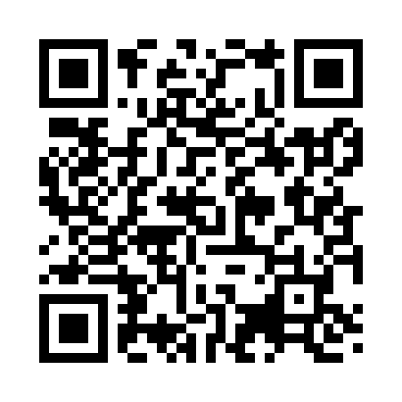
Prayer times for Nukus, Uzbekistan
Wed 1 May 2024 - Fri 31 May 2024
High Latitude Method: None
Prayer Calculation Method: Muslim World League
Asar Calculation Method: Shafi

Date | Day | Fajr | Sunrise | Dhuhr | Asr | Maghrib | Isha
1 | Wed | 4:07 | 5:56 | 12:59 | 4:52 | 8:02 | 9:44
2 | Thu | 4:05 | 5:55 | 12:59 | 4:52 | 8:03 | 9:46
3 | Fri | 4:03 | 5:54 | 12:58 | 4:53 | 8:04 | 9:48
4 | Sat | 4:01 | 5:52 | 12:58 | 4:53 | 8:05 | 9:49
5 | Sun | 3:59 | 5:51 | 12:58 | 4:53 | 8:06 | 9:51
6 | Mon | 3:57 | 5:50 | 12:58 | 4:54 | 8:07 | 9:53
7 | Tue | 3:55 | 5:49 | 12:58 | 4:54 | 8:08 | 9:54
8 | Wed | 3:53 | 5:47 | 12:58 | 4:54 | 8:09 | 9:56
9 | Thu | 3:52 | 5:46 | 12:58 | 4:55 | 8:10 | 9:58
10 | Fri | 3:50 | 5:45 | 12:58 | 4:55 | 8:12 | 9:59
11 | Sat | 3:48 | 5:44 | 12:58 | 4:55 | 8:13 | 10:01
12 | Sun | 3:46 | 5:43 | 12:58 | 4:56 | 8:14 | 10:03
13 | Mon | 3:45 | 5:42 | 12:58 | 4:56 | 8:15 | 10:04
14 | Tue | 3:43 | 5:41 | 12:58 | 4:56 | 8:16 | 10:06
15 | Wed | 3:41 | 5:40 | 12:58 | 4:57 | 8:17 | 10:07
16 | Thu | 3:40 | 5:39 | 12:58 | 4:57 | 8:18 | 10:09
17 | Fri | 3:38 | 5:38 | 12:58 | 4:57 | 8:19 | 10:11
18 | Sat | 3:36 | 5:37 | 12:58 | 4:58 | 8:20 | 10:12
19 | Sun | 3:35 | 5:36 | 12:58 | 4:58 | 8:21 | 10:14
20 | Mon | 3:33 | 5:35 | 12:58 | 4:58 | 8:22 | 10:15
21 | Tue | 3:32 | 5:34 | 12:58 | 4:59 | 8:23 | 10:17
22 | Wed | 3:30 | 5:33 | 12:58 | 4:59 | 8:24 | 10:18
23 | Thu | 3:29 | 5:33 | 12:58 | 4:59 | 8:25 | 10:20
24 | Fri | 3:27 | 5:32 | 12:58 | 5:00 | 8:26 | 10:21
25 | Sat | 3:26 | 5:31 | 12:59 | 5:00 | 8:27 | 10:23
26 | Sun | 3:25 | 5:30 | 12:59 | 5:00 | 8:27 | 10:24
27 | Mon | 3:23 | 5:30 | 12:59 | 5:01 | 8:28 | 10:26
28 | Tue | 3:22 | 5:29 | 12:59 | 5:01 | 8:29 | 10:27
29 | Wed | 3:21 | 5:28 | 12:59 | 5:01 | 8:30 | 10:29
30 | Thu | 3:20 | 5:28 | 12:59 | 5:01 | 8:31 | 10:30
31 | Fri | 3:19 | 5:27 | 12:59 | 5:02 | 8:32 | 10:31
Prayer times provided by https://www.salahtimes.com

