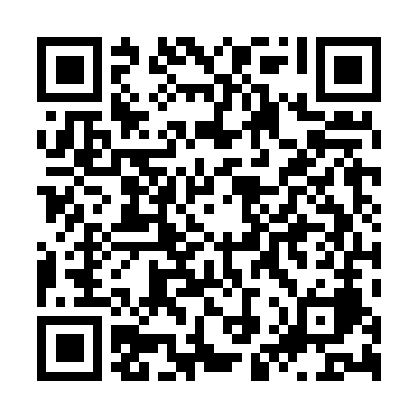
Prayer times for Chalatenango, El Salvador
Wed 1 May 2024 - Fri 31 May 2024
High Latitude Method: None
Prayer Calculation Method: Muslim World League
Asar Calculation Method: Shafi

Date | Day | Fajr | Sunrise | Dhuhr | Asr | Maghrib | Isha
1 | Wed | 4:19 | 5:34 | 11:53 | 3:02 | 6:12 | 7:23
2 | Thu | 4:18 | 5:33 | 11:53 | 3:03 | 6:12 | 7:23
3 | Fri | 4:18 | 5:33 | 11:53 | 3:03 | 6:13 | 7:23
4 | Sat | 4:17 | 5:32 | 11:52 | 3:04 | 6:13 | 7:24
5 | Sun | 4:17 | 5:32 | 11:52 | 3:04 | 6:13 | 7:24
6 | Mon | 4:16 | 5:31 | 11:52 | 3:05 | 6:13 | 7:24
7 | Tue | 4:16 | 5:31 | 11:52 | 3:05 | 6:14 | 7:25
8 | Wed | 4:15 | 5:31 | 11:52 | 3:06 | 6:14 | 7:25
9 | Thu | 4:15 | 5:30 | 11:52 | 3:06 | 6:14 | 7:25
10 | Fri | 4:14 | 5:30 | 11:52 | 3:07 | 6:14 | 7:26
11 | Sat | 4:14 | 5:30 | 11:52 | 3:08 | 6:15 | 7:26
12 | Sun | 4:13 | 5:29 | 11:52 | 3:08 | 6:15 | 7:27
13 | Mon | 4:13 | 5:29 | 11:52 | 3:09 | 6:15 | 7:27
14 | Tue | 4:12 | 5:29 | 11:52 | 3:09 | 6:15 | 7:27
15 | Wed | 4:12 | 5:29 | 11:52 | 3:10 | 6:16 | 7:28
16 | Thu | 4:12 | 5:28 | 11:52 | 3:10 | 6:16 | 7:28
17 | Fri | 4:11 | 5:28 | 11:52 | 3:11 | 6:16 | 7:29
18 | Sat | 4:11 | 5:28 | 11:52 | 3:11 | 6:17 | 7:29
19 | Sun | 4:11 | 5:28 | 11:52 | 3:12 | 6:17 | 7:30
20 | Mon | 4:10 | 5:28 | 11:52 | 3:12 | 6:17 | 7:30
21 | Tue | 4:10 | 5:27 | 11:52 | 3:12 | 6:17 | 7:30
22 | Wed | 4:10 | 5:27 | 11:52 | 3:13 | 6:18 | 7:31
23 | Thu | 4:09 | 5:27 | 11:53 | 3:13 | 6:18 | 7:31
24 | Fri | 4:09 | 5:27 | 11:53 | 3:14 | 6:18 | 7:32
25 | Sat | 4:09 | 5:27 | 11:53 | 3:14 | 6:19 | 7:32
26 | Sun | 4:09 | 5:27 | 11:53 | 3:15 | 6:19 | 7:33
27 | Mon | 4:09 | 5:27 | 11:53 | 3:15 | 6:19 | 7:33
28 | Tue | 4:08 | 5:27 | 11:53 | 3:16 | 6:20 | 7:33
29 | Wed | 4:08 | 5:27 | 11:53 | 3:16 | 6:20 | 7:34
30 | Thu | 4:08 | 5:27 | 11:53 | 3:16 | 6:20 | 7:34
31 | Fri | 4:08 | 5:27 | 11:54 | 3:17 | 6:21 | 7:35
Prayer times provided by https://www.salahtimes.com

