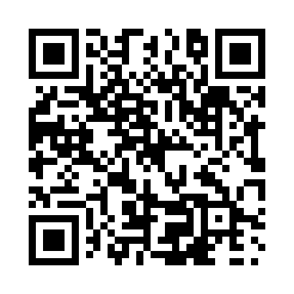
Prayer times for Bergman, Alberta, Canada
Mon 1 Apr 2024 - Tue 30 Apr 2024
High Latitude Method: Angle Based Rule
Prayer Calculation Method: Islamic Society of North America
Asar Calculation Method: Hanafi

Date | Day | Fajr | Sunrise | Dhuhr | Asr | Maghrib | Isha
1 | Mon | 5:23 | 7:05 | 1:37 | 6:04 | 8:10 | 9:52
2 | Tue | 5:21 | 7:03 | 1:37 | 6:05 | 8:12 | 9:55
3 | Wed | 5:18 | 7:00 | 1:37 | 6:07 | 8:14 | 9:57
4 | Thu | 5:15 | 6:58 | 1:36 | 6:08 | 8:16 | 9:59
5 | Fri | 5:12 | 6:56 | 1:36 | 6:09 | 8:18 | 10:02
6 | Sat | 5:09 | 6:53 | 1:36 | 6:11 | 8:19 | 10:04
7 | Sun | 5:06 | 6:51 | 1:36 | 6:12 | 8:21 | 10:07
8 | Mon | 5:03 | 6:48 | 1:35 | 6:13 | 8:23 | 10:09
9 | Tue | 5:00 | 6:46 | 1:35 | 6:14 | 8:25 | 10:12
10 | Wed | 4:57 | 6:44 | 1:35 | 6:16 | 8:27 | 10:14
11 | Thu | 4:54 | 6:41 | 1:34 | 6:17 | 8:29 | 10:17
12 | Fri | 4:51 | 6:39 | 1:34 | 6:18 | 8:30 | 10:19
13 | Sat | 4:48 | 6:37 | 1:34 | 6:19 | 8:32 | 10:22
14 | Sun | 4:45 | 6:34 | 1:34 | 6:21 | 8:34 | 10:24
15 | Mon | 4:42 | 6:32 | 1:33 | 6:22 | 8:36 | 10:27
16 | Tue | 4:39 | 6:30 | 1:33 | 6:23 | 8:38 | 10:30
17 | Wed | 4:35 | 6:28 | 1:33 | 6:24 | 8:40 | 10:32
18 | Thu | 4:32 | 6:25 | 1:33 | 6:26 | 8:41 | 10:35
19 | Fri | 4:29 | 6:23 | 1:33 | 6:27 | 8:43 | 10:38
20 | Sat | 4:26 | 6:21 | 1:32 | 6:28 | 8:45 | 10:40
21 | Sun | 4:23 | 6:19 | 1:32 | 6:29 | 8:47 | 10:43
22 | Mon | 4:20 | 6:16 | 1:32 | 6:30 | 8:49 | 10:46
23 | Tue | 4:16 | 6:14 | 1:32 | 6:32 | 8:50 | 10:49
24 | Wed | 4:13 | 6:12 | 1:32 | 6:33 | 8:52 | 10:52
25 | Thu | 4:10 | 6:10 | 1:31 | 6:34 | 8:54 | 10:55
26 | Fri | 4:07 | 6:08 | 1:31 | 6:35 | 8:56 | 10:58
27 | Sat | 4:03 | 6:06 | 1:31 | 6:36 | 8:58 | 11:01
28 | Sun | 4:00 | 6:04 | 1:31 | 6:37 | 9:00 | 11:04
29 | Mon | 3:56 | 6:01 | 1:31 | 6:38 | 9:01 | 11:07
30 | Tue | 3:53 | 5:59 | 1:31 | 6:39 | 9:03 | 11:10
Prayer times provided by https://www.salahtimes.com

