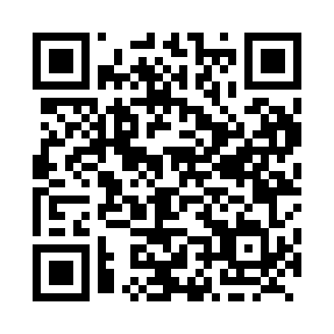
Prayer times for Kakisa, Northwest Territories, Canada
Wed 1 May 2024 - Fri 31 May 2024
High Latitude Method: Angle Based Rule
Prayer Calculation Method: Islamic Society of North America
Asar Calculation Method: Hanafi

Date | Day | Fajr | Sunrise | Dhuhr | Asr | Maghrib | Isha
1 | Wed | 3:44 | 5:40 | 1:47 | 7:06 | 9:55 | 11:51
2 | Thu | 3:42 | 5:37 | 1:47 | 7:08 | 9:57 | 11:52
3 | Fri | 3:41 | 5:35 | 1:46 | 7:09 | 10:00 | 11:53
4 | Sat | 3:39 | 5:32 | 1:46 | 7:11 | 10:02 | 11:55
5 | Sun | 3:38 | 5:29 | 1:46 | 7:12 | 10:05 | 11:56
6 | Mon | 3:37 | 5:26 | 1:46 | 7:14 | 10:08 | 11:57
7 | Tue | 3:35 | 5:23 | 1:46 | 7:15 | 10:10 | 11:59
8 | Wed | 3:34 | 5:21 | 1:46 | 7:17 | 10:13 | 12:00
9 | Thu | 3:32 | 5:18 | 1:46 | 7:18 | 10:15 | 12:01
10 | Fri | 3:31 | 5:15 | 1:46 | 7:19 | 10:18 | 12:02
11 | Sat | 3:30 | 5:13 | 1:46 | 7:21 | 10:20 | 12:04
12 | Sun | 3:28 | 5:10 | 1:46 | 7:22 | 10:23 | 12:05
13 | Mon | 3:27 | 5:08 | 1:46 | 7:23 | 10:26 | 12:06
14 | Tue | 3:26 | 5:05 | 1:46 | 7:25 | 10:28 | 12:07
15 | Wed | 3:25 | 5:03 | 1:46 | 7:26 | 10:31 | 12:09
16 | Thu | 3:24 | 5:00 | 1:46 | 7:27 | 10:33 | 12:10
17 | Fri | 3:22 | 4:58 | 1:46 | 7:29 | 10:35 | 12:11
18 | Sat | 3:21 | 4:56 | 1:46 | 7:30 | 10:38 | 12:12
19 | Sun | 3:20 | 4:53 | 1:46 | 7:31 | 10:40 | 12:14
20 | Mon | 3:19 | 4:51 | 1:46 | 7:32 | 10:43 | 12:15
21 | Tue | 3:18 | 4:49 | 1:46 | 7:33 | 10:45 | 12:16
22 | Wed | 3:17 | 4:47 | 1:46 | 7:35 | 10:47 | 12:17
23 | Thu | 3:16 | 4:44 | 1:47 | 7:36 | 10:50 | 12:18
24 | Fri | 3:15 | 4:42 | 1:47 | 7:37 | 10:52 | 12:20
25 | Sat | 3:14 | 4:40 | 1:47 | 7:38 | 10:54 | 12:21
26 | Sun | 3:13 | 4:38 | 1:47 | 7:39 | 10:56 | 12:22
27 | Mon | 3:12 | 4:36 | 1:47 | 7:40 | 10:58 | 12:23
28 | Tue | 3:11 | 4:35 | 1:47 | 7:41 | 11:01 | 12:24
29 | Wed | 3:10 | 4:33 | 1:47 | 7:42 | 11:03 | 12:25
30 | Thu | 3:09 | 4:31 | 1:47 | 7:43 | 11:05 | 12:26
31 | Fri | 3:09 | 4:29 | 1:47 | 7:44 | 11:06 | 12:27
Prayer times provided by https://www.salahtimes.com

