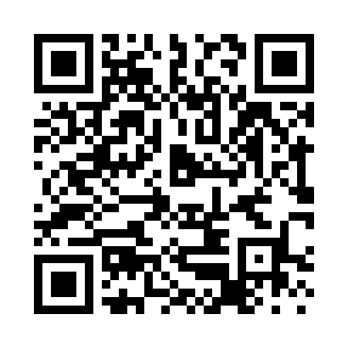
Prayer times for Tebourba, Tunisia
Wed 1 May 2024 - Fri 31 May 2024
High Latitude Method: Angle Based Rule
Prayer Calculation Method: Tunisian Ministry of Religious Affairs
Asar Calculation Method: Shafi

Date | Day | Fajr | Sunrise | Dhuhr | Asr | Maghrib | Isha
1 | Wed | 3:49 | 5:26 | 12:18 | 4:04 | 7:10 | 8:47
2 | Thu | 3:48 | 5:25 | 12:18 | 4:04 | 7:11 | 8:48
3 | Fri | 3:46 | 5:24 | 12:18 | 4:05 | 7:11 | 8:50
4 | Sat | 3:45 | 5:23 | 12:17 | 4:05 | 7:12 | 8:51
5 | Sun | 3:43 | 5:22 | 12:17 | 4:05 | 7:13 | 8:52
6 | Mon | 3:42 | 5:21 | 12:17 | 4:05 | 7:14 | 8:53
7 | Tue | 3:41 | 5:20 | 12:17 | 4:05 | 7:15 | 8:55
8 | Wed | 3:39 | 5:19 | 12:17 | 4:05 | 7:16 | 8:56
9 | Thu | 3:38 | 5:18 | 12:17 | 4:06 | 7:17 | 8:57
10 | Fri | 3:36 | 5:17 | 12:17 | 4:06 | 7:18 | 8:58
11 | Sat | 3:35 | 5:16 | 12:17 | 4:06 | 7:18 | 9:00
12 | Sun | 3:34 | 5:15 | 12:17 | 4:06 | 7:19 | 9:01
13 | Mon | 3:33 | 5:14 | 12:17 | 4:06 | 7:20 | 9:02
14 | Tue | 3:31 | 5:14 | 12:17 | 4:06 | 7:21 | 9:03
15 | Wed | 3:30 | 5:13 | 12:17 | 4:07 | 7:22 | 9:05
16 | Thu | 3:29 | 5:12 | 12:17 | 4:07 | 7:23 | 9:06
17 | Fri | 3:28 | 5:11 | 12:17 | 4:07 | 7:23 | 9:07
18 | Sat | 3:27 | 5:10 | 12:17 | 4:07 | 7:24 | 9:08
19 | Sun | 3:25 | 5:10 | 12:17 | 4:07 | 7:25 | 9:10
20 | Mon | 3:24 | 5:09 | 12:17 | 4:07 | 7:26 | 9:11
21 | Tue | 3:23 | 5:08 | 12:17 | 4:08 | 7:27 | 9:12
22 | Wed | 3:22 | 5:08 | 12:17 | 4:08 | 7:27 | 9:13
23 | Thu | 3:21 | 5:07 | 12:17 | 4:08 | 7:28 | 9:14
24 | Fri | 3:20 | 5:07 | 12:18 | 4:08 | 7:29 | 9:15
25 | Sat | 3:19 | 5:06 | 12:18 | 4:08 | 7:30 | 9:16
26 | Sun | 3:19 | 5:05 | 12:18 | 4:09 | 7:30 | 9:18
27 | Mon | 3:18 | 5:05 | 12:18 | 4:09 | 7:31 | 9:19
28 | Tue | 3:17 | 5:05 | 12:18 | 4:09 | 7:32 | 9:20
29 | Wed | 3:16 | 5:04 | 12:18 | 4:09 | 7:33 | 9:21
30 | Thu | 3:15 | 5:04 | 12:18 | 4:09 | 7:33 | 9:22
31 | Fri | 3:15 | 5:03 | 12:18 | 4:10 | 7:34 | 9:23
Prayer times provided by https://www.salahtimes.com

